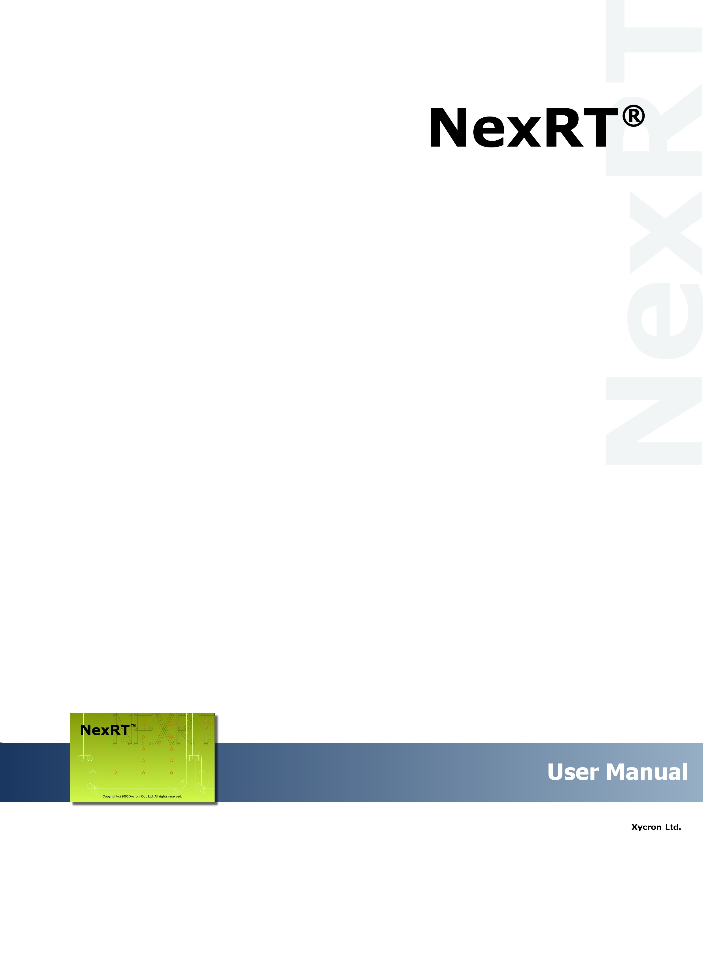

March, 2007

목차
1. Intro 10
1-1. About NexRT 10
1-2. Composition of NexRTMode 11
1-3. NexRT Mode 13
1-4. Vector Type 14
1-4-1 Guide Drill 14
1-4-2 Normal Drill 14
1-4-3 Spiral Round 14
1-4-4 Spiral Square 15
1-4-5 Spiral Rectangle 15
1-4-6 Spiral Oblong 16
1-4-7 Window 16
1-4-8 Slot 16
1-4-10 Outline 17
1-5. Compensation 18
2. File 19
2-1. New 19
2-2. Open 19
2-3. Save 20
2-4. Save As.. 20
2-5. Import ▶ 20
2-5-1. Gerber, Drill.. 20
2-5-2. Dr. Router.. 23
2-6. Export ▶ 23
2-6-1. Router… 24
2-6-2. GIF… 25
2-7. Recent file 26
2-8. Exit 26
3. Information 27
3-1. Measure Distance 27
3-2. Measure Object 27
3-3. Measure Angle 28
3-4. Query Object 28
4. Select 29
4-1. Select Object 30
4-2. Select Object By Area 30
4-3. Select Object By Polygon 30
4-4. Select All 30
4-5. Select Object By Condition 30
4-6. Select Tool 33
4-7. Select Object By Tool 33
5. Buffer 35
5-1. Undo 35
5-2. Redo 35
5-3. Remove Buffer 35
6. Edit(Gerber) 36
6-1. Delete ▶ 36
6-1-1. Delete Vector 36
6-2. Copy ▶ 36
6-3. Move ▶ 38
6-3-1. Move Object 38
6-3-2. Align Layer Manually.. 39
6-3-3. Align Layer To Datum Manually 39
6-3-4. Change Origin Point By Line Intersection 39
6-3-5. Gerber To Router.. 39
6-4. Transform 41
6-5. Chain ▶ 42
6-5-1. Chain 42
6-5-2. Unchain 43
6-6. Reshape ▶ 43
6-6-1. Sectorize Arc.. 43
6-6-2. DeSectorize.. 45
7. Edit(Router) 46
7-1. Delete 46
7-1-1. Delete 46
7-2. Copy ▶ 46
7-2-1. Object 47
7-2-2. As Step-Repeat.. 47
7-2-3. All Object..(Layer) 47
7-3. Move ▶ 49
7-3-1. Object 49
7-3-2. Align Layer Manually.. 49
7-3-3. Align Layer To Datum Manually 49
7-4. Transform 49
7-5. Chain ▶ 49
7-5-1. Chain 49
7-5-2. Unchain 49
7-6. Change ▶ 50
7-6-1. Tool.. 50
7-6-2. Order 51
7-6-3. Change Order 51
7-6-4. Panel Order 51
7-6-5. Reset Dcode 52
7-6-6. Router Vector Attribute 52
7-7. Reshape ▶ 53
7-7-1. Change Direction 53
7-7-2. Sectorize Arc.. 53
7-7-3. Desectorize Arc.. 53
7-7-4. Change Arc Direction 54
7-7-5. Chamfer 54
7-7-6. Link Line 55
7-7-7. Attach 55
7-7-8. Break 56
7-8. Vertex ▶ 56
7-8-1. Delete 56
7-8-2. Move 56
8. Edit(Popcopy) 58
8-1. Select popcopy 58
8-2. Add popcopy 58
8-3. Delete popcopy 58
8-4. Move popcopy 59
8-5. Resize popcopy 59
8-6. Change popcopy attribute 59
8-7. Add scoring.. 60
8-8. Add beveling.. 62
8-9. Add description.. 64
9. Edit(Dimension) 67
9-1. Delete 67
9-2. Move 67
9-3. Change 67
9-3-1. Change Dimension 68
9-3-2. Dimension Font Size 68
10. Edit(Layout) 69
10-1. Delete Layout ▶ 69
10-2. Move Layout ▶ 69
10-3. Change ▶ 69
10-3-1. Resize 69
10-3-2. Resize by Percent.. 70
11. Add 71
11-1. Pad 72
11-2. Line(Start-End) 74
11-3. Line(Center) 74
11-4. Line(Poly) 75
11-5. Arc(Center-Start-End) 75
11-6. Arc (Start-End-Center) 76
11-7. Arc(1-2-3) 76
11-8. Arc(Center) 77
11-9. Circle(Start-End) 77
11-10. Rectangle(Center) 78
11-11. Rectangle(Start-End) 78
11-12. Vertex 79
11-13. Dwell 79
11-14. Mesh Line 80
11-15. Start-End Point 81
11-16. Special Vectors 82
11-16-1. Tangent Line to the Arc (Point) 82
11-16-2. Tangent Circle to the Line 83
11-16-3. Tangent Circle to the Arc 83
11-16-4. Tangent Line to the Arc (Angle) 84
11-16-5. Tangent Line to Two Arcs 84
11-16-6. Tangent Circle to Two Arcs 85
11-17. Break Away Hole 86
12. Add(Dimension) 88
12-1. Horizontal 88
12-2. Vertical 89
12-3. Diagonal 89
12-4. Pointed 90
12-5. Radius 90
12-6. Angle 90
12-7. Text 91
12-8. Arc 91
12-9. Cornercut 91
12-10. Guide Line 92
12-11. Horizontal On Slope 92
12-12. Vertical On Slope 93
12-13. Diagonal On Vector 93
13. Insert(Layout) 94
13-1. Insert popcopy 94
13-2. Insert Scoring 95
13-3. Insert Beveling 95
13-4. Insert Description 96
14. View 97
14-1. Draw ▶ 97
14-1-1. Home 98
14-1-2. Set Home 98
14-1-3. Redraw 98
14-1-4. Draw All 98
14-2. Zoom & Panning ▶ 98
14-2-1. Zoom In 99
14-2-2. Zoom Out 99
14-2-3. Zoom Area 99
14-2-4. Panning 99
14-2-5. Panning Left 99
14-2-6. Panning Right 99
14-2-7. Panning Up 100
14-2-8. Panning Down 100
14-3. View Mode GB/DR ▶ 100
14-4. View Mode RT ▶ 101
14-5. View Mark ▶ 101
14-5-1. Start Point 102
14-5-2. Middle Point 102
14-5-3. Direction 102
14-6. Grid 103
14-7. Search Area 103
14-8. Profile 103
14-9. Step-Repeat 104
15. Job 105
15-1. Setting... 105
15-2. Report... 105
16. Layout 106
16-1. Set Active Layout ▶ 106
16-2. Add layout.. 106
16-3. Delete layout 107
17. Work 108
17-1. Set Active Work ▶ 108
17-2. Add Step & Repeat 108
17-3. Setting... 109
18. Layer 110
18-1. Create Router Layer... 110
18-2. Setting.. 110
19. Utility 112
19-.1 Compare Layers 112
20. Tool 114
20-1. CAM Manager… 114
20-1-1. Work Manager 114
20-2. Tool Manager.. 117
20-3. Chalk Template Manager 122
20-4. Customize... 125
20-5. Option 126
21. Simulation 152
21-1. Simulation 152
21-2. Change Direction 153
21-3. Router Vector Attribute 153
21-4. Report Process Times & Length 154
21-5. DRC Report 155

1. Intro

1-1. About NexRT

The exterior of PCB is getting more complex lately according to the trend of high function, high precision, miniaturization, and the combination of analog and digital. Therefore, the exterior processing, the last processing in the PCB manufacture, has generated problems due to the use of text editor level exclusive router editor attached to the router machine or an editor for router data for machine.

First, it offers output limited to only one router format so that formats differ in using various router formats, resulting in difficulty in training the operator and managing data.
Second, in dealing with complex PCB operation beyond the capability of text editor level programming, much time is necessary and errors may occur.
Third, diversified router paths are difficult to draw due to the absence of a tool exclusively for PCB router.
Fourth, there is no way to verify the output data.

Developed to solve the problems above, NexRT
1. Helps the beginner as well as the expert produce perfect router data in a short training period because it has windows GUI environment familiar to general computer users.
2. Supports most of files used in PCB industry by perfect import of Gerber(274X/274D/MDA), Dxf, and ODB files.
3. Supports output format of various devices (Hitachi, Excellon, RokuRoku, Takeuchi, etc) in the identical GUI environment so that additional purchase of exclusive programming is not necessary and the integrated data management is realized.
4. Supports the simulation function to check the output order and compensation of processing data before the real output data, and exact time for real processing by pre-checking of processing distance, transfer distance, etc.
5. Offers router exclusive DRC function to prevent erroneous processing in advance.
6. Supports the drawing function to draw and manage drawings for filing and field by input of dimension, text, and table after router data process.

These functions are standardized by a program with know-hows about preparation and processing of real router data.

1-2. Composition of NexRTMode

NexRT consists of Menu, ToolBar, View, Layer Bar, Output Bar, Bird’s eye Bar, and Status Bar.

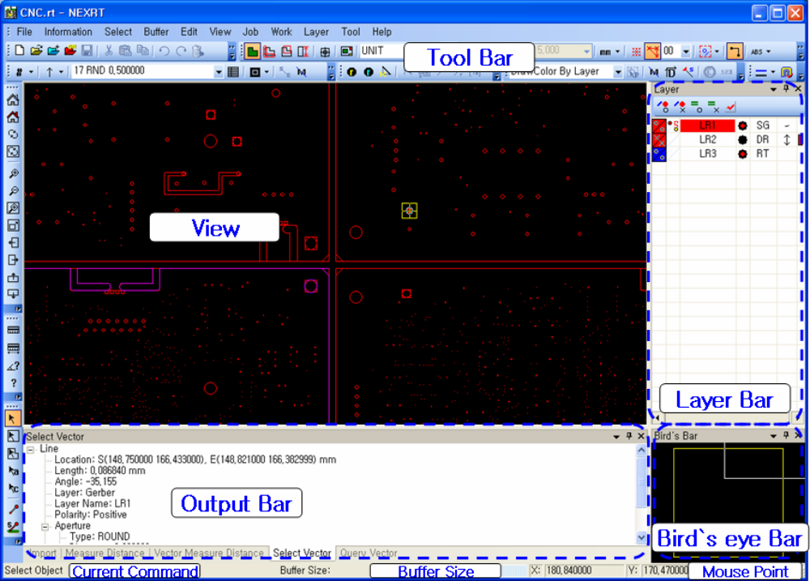
Current Command
Display the current command mode.
Buffer Size
Display the Edit Buffer Size for Undo/Redo.
Mouse Point
Display the current mouse point on the view.
Bird`s Eye Bar
Display the data area presented on the current view among all data.
Output Bar
Display the result of functions such as Select, Query, Measure, etc.

Layer List
Display the layer list.
● Layer Color/Draw Icon 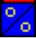
This icon represents the color and drawing availability of each layer. Color is changeable by right mouse click, and drawing availability is toggled by each left mouse click.
Upper Left Area: Vector drawing
Lower Right Area: Flash drawing
● Active/Affected/Snap Layer Icon 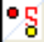
“o”sign in the upper left means the active Layer. When the layer is activated, Chalks (aperture, drill tool) are indicated in the chalk bar. “o”sign in the lower right means that the layer is specified as affected Layer. Click on the right mouse button to specify the selected layer as Snap Layer.

● Polarity/Data existence Icon

Positive,  data exist | Positive,  data don’t exist | Negative,  data exist | Negative,  data don’t exist
● All Layer Draw On Icon 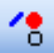
● All Layer Draw Off Icon 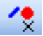
● All Layer Affection On Icon 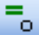
● All Layer Affection Off Icon 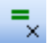
● Layer Mode

Signal Layer | Power/Ground Layer | Mix Layer | Solder Mask Layer
SG | PG | MX | SM
Silk Screen Layer | Graphic Layer | Drill Layer | Router Layer
SS | GP | DR | RT

1-3. NexRT Mode

NexRT consists of 6 modes, which vary in function.
● Work Mode 
This is a mode for data input/output and Gerber/router data editing.
In detail, the mode is classified as Gerber/Drill/Router according to the properties of layer.
● Simulation Mode 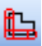
This is a mode to check the produced router data by Simulation/DRC/Report.
● Popcopy Mode 
A mode for adding/editing the popcopy to produce drawings.
● Dimension Mode 
A mode for adding/editing the dimension to produce drawings.
● Layout Mode 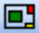
A mode for producing drawings by data prepared at the Popcopy/Dimension data mode.
● Symbol Mode 
A mode for managing symbol data.
Not used for the router work.

1-4. Vector Type

1-4-1 Guide Drill
‘Guide Drill’ is the drill hole used to insert a guide pin at the backlight to stabilize the PCB. When ‘Guide Drill’ is outputting, a separate output is generated.

1-4-2 Normal Drill
Normally, the drill hole is made at the drill manufacturing process. However, when the drill is made at the router manufacturing process, it is called ‘Normal Drill’.

1-4-3 Spiral Round
‘Spiral Round’ is used when the hole is too big to be processed at once. It processes the bit along the data’s external circle and scraps the data’s internal part. It assigns a drill’s center point. Depending on the drill’s size, there are three different methods to process ‘Spiral Round’. Let’s call the drill size M and the bit size T.

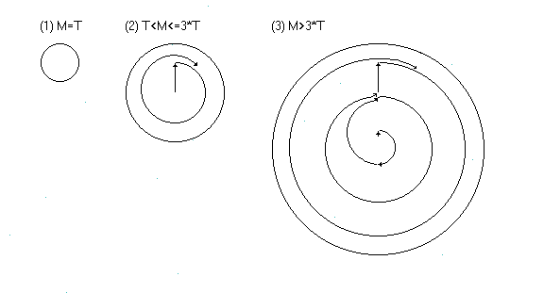

1-4-4 Spiral Square
‘Spiral Square’ is a rectangular shape route data and excepting different data’s shape, processing method is same as ‘Spiral Round’.

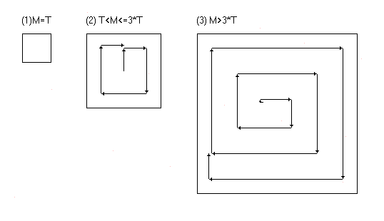

1-4-5 Spiral Rectangle
‘Spiral Rectangle’ is a rectangular shaped route data. It assigns the data’s center point coordinate, X-size, Y-size and angle. Processing method is different depending on X-size, Y-size and bit size. If we call the minimum value of either X-size or Y-size M and bit size T, then there are three methods to process the router data as shown below.

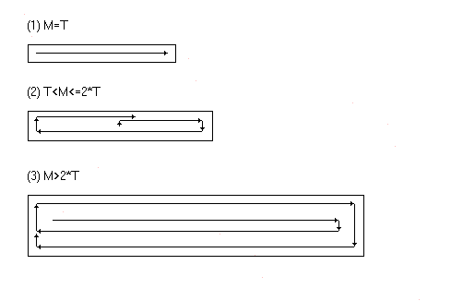

1-4-6 Spiral Oblong
Excepting the different movement for data’s both end’s bit, ‘Spiral Oblong’ has the same processing method as ‘Spiral Rectangle’.

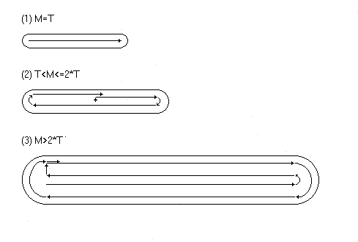

1-4-7 Window
‘Window’ is internal PCB’s non standardized closed curve.

1-4-8 Slot
For ‘Slot’, there are two processing methods depending on whether to apply compensation or not. Diagram A shows slot’s processing method when applying compensation. When generating a solid line, the bit processes along the dotted line. Diagram B shows slot 1’s processing method when compensation is not applied. The bit moves along the dotted line located inside 2 solid lines. In this case, data has to be closed and the space between 2 solid lines has to be same as the bit size.

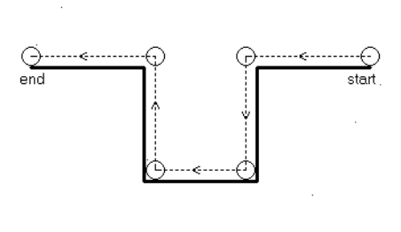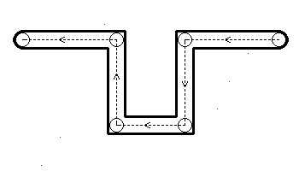

1-4-10 Outline
‘Outline’ is PCB’s external route data.

1-5. Compensation

If a bit is processed along the data’s exterior, then either smaller or bigger data is produced while processing router data. Therefore, in order to produce the right data size, it should be drawn bigger or smaller by 1/2 the bit size of the original data. However, ‘Compensation Setting’ helps to produces the right data size by applying compensation to the left or right.

Left(G41) | None(G40) | Right(G42)
 | 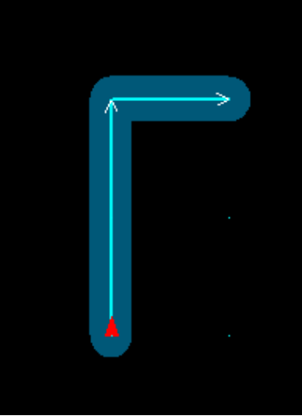 | 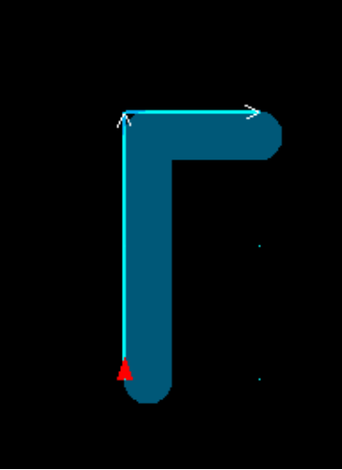

2. File

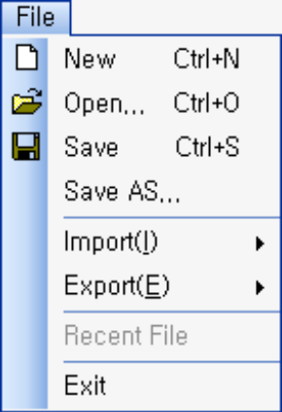 | New
 | Create a new project.
 | Open
 | Open a previously saved project.
 | Save
 | Save the current project.
 | Save As..
 | Save the current project as a new name.
 | Import ▶
 | Import data in diversified forms.
 | Export ▶
 | Export data in diversified forms.
 | Recent File
 | Open a recent project.
 | Exit
 | Exit the program.

2-1. New
Use this menu to remove the contents of the current project and prepare a new project. If there is something changed in the current project, a dialog box will pop up and ask whether you want to save the current project or not. You can select OK or Cancel in this dialog box. If you select OK button, the current project will be saved before the creation of a new project, and if you select Cancel button, the current project will not be saved and a new project will be prepared.

2-2. Open
Use this menu to remove the contents of the current project and open a previously saved project. If there is something changed in the current project, a dialog box will pop up and ask whether you want to save the current project or not. You can select OK or Cancel in this dialog box. If you select OK button, the current project will be saved before opening of the previously saved project, and if you select Cancel button, the current project will not be saved and the previously saved project will be opened.

2-3. Save
Use this menu to save the current project for later use. If the name of the project is not given, a <save this file as> dialog box will pop up, and if the name of the project is already given, it will be saved with the name.

2-4. Save As..
Use this menu to save the current project for later use. All actions are the same as the Save menu, but this is to save the project with a new name.

2-5. Import ▶

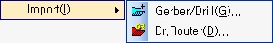 | Gerber, Drill..
 | Import Gerber file and drill file to create a layer.
 | Dr. Router..
 | Import Dr. Router project.

2-5-1. Gerber, Drill..
Use this menu to import a new file to add a layer to the current work. When a file dialog box pops up, select the desired file and click open. Then <Format Page> dialog box pops up after the analysis of the file type.

Format page : Gerber
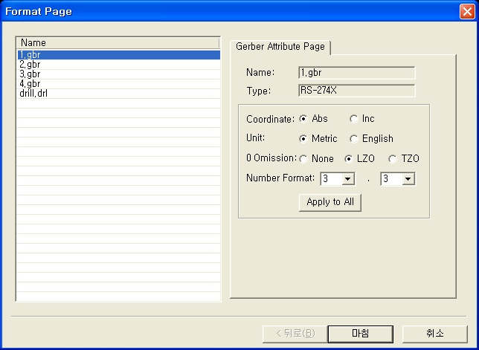

File list
A file list to import.
File name
A file name selected in the file list.
File type
A file type selected in the file list.
Coordinate
Set up a coordinate to read the selected file by.
Unit
Set up a unit system to read the selected file by.
0 omission
Set up a 0 omission method to read a selected file with.
Number format
Set up a number format to read the selected file by.
Apply to all
Apply the setup values in this Format Page to all Gerber or drill files.

Format page : Drill
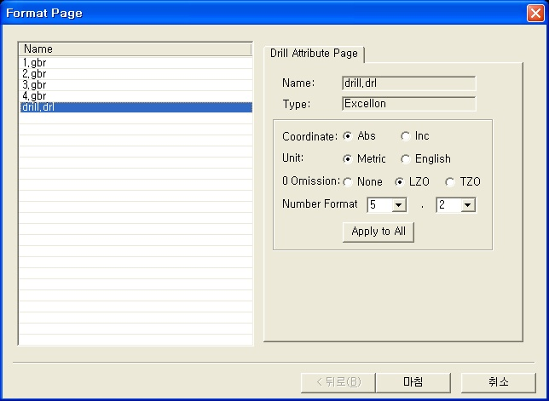
File list
A file list to import.
File name
A file name selected in the file list.
File type
A file type selected in the file list.
Coordinate
Set up a coordinate to read the selected file by.
Unit
Set up a unit system to read the selected file by.
0 omission
Set up a 0 omission method to read the selected file with.
Number format
Set up a number format to read the selected file by.
Apply to all
Apply the setup values in this Format Page to all Gerber or drill files.

Click OK and <Matrix Manager> dialog box will pop up. This dialog box is similar to the work manager of <Tool : CAM Manager>.

Matrix manager
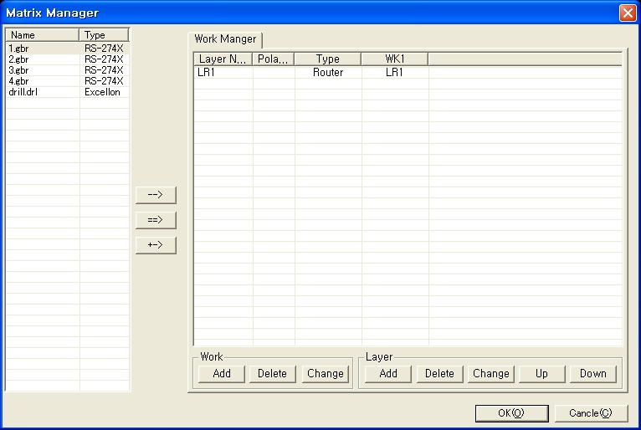

File list
A file list to import.
Import a layer : -→
- Importing as a new layer
Select a work, and a file, and click the button to add a new layer to the relevant work. Just click the work name to select a work.
- Overwriting the existing layer
Select a physical layer, and a file, and click the button to overwrite the relevant physical layer with the information of the selected file. Just select the section where the layer name and work name crosses to select a physical layer.
(e.g.) Select LR1 where the layer name (LR1) and work name(WK1) crosses in the dialog box above.
Import all layers : ==>
Select a work and click the button to add all files to the relevant work as a new layer.
Import a layer : +->
Select a work, and a file, and click the button to add a new layer to the relevant work. Just click the work name to select a work.
Work Manager
This is similar to the work manager of <Tool: CAM Manager>. Refer to <TOOL : CAM Manager> for details.

2-5-2. Dr. Router..
Use this menu to remove the contents of the current project and open a Dr. Router project. When the file dialog box pops up, select the desired Dr. Router project(.prj) and click open. Then Dr. Router project will open.

2-6. Export ▶

Router… (Simulation Mode)
Export a Router NC file.

GIF… (Layout Mode)
Export a GIF file.

2-6-1. Router…
Use this menu to output the current active layer, and indicate the format and location of output.

Router Output Dialog

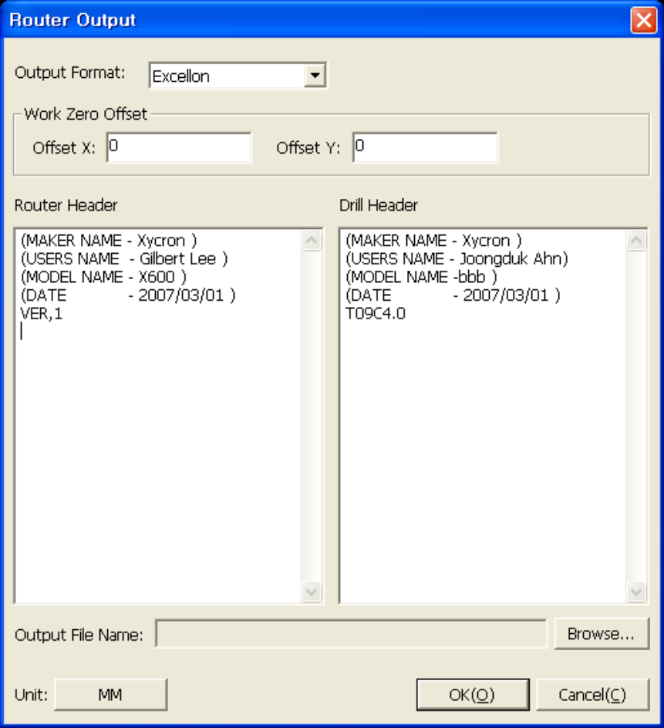
Output
Indicate the format type of Router data to output.
Router Header
Verify the Router Header to be output, and change finally.
Drill Header
Verify the drill Header to output, and change finally.
Output File Name
Indicate the file path on which the Router data are to be output.

2-6-2. GIF…

GIF Option
File Path
File Path for a GIF file to be created.
Color
It supports 3 color mode.

- Color (256 color)
- Gray Scale
Each vector is printed balancing the black and white in consideration of brightness according to its color.

- Black & White
Each vector is printed with the vector as black, and the background as white.

Resolution (DPI)
It supports 100 to 400 DPI.

2-7. Recent file
This displays the list of the projects recently worked on. Select a project on the list to get the project easily.

2-8. Exit
Exit the program. If there is unsaved information, a warning pane will pop up.

3. Information

Measure Distance
Measure the distance between the two points.
Measure Object
Measure the distance between the two vectors.
Measure Angle
Measure the angle between the two vectors.
Query Object
Display the detailed attributes(types of data, location, size, etc.) of an object.

3-1. Measure Distance
Use this menu to simply measure the distance between two points in the current work window area. It is measured with the grid snap and the vector snap. Click the Measure Distance menu and move the cursor on the desired location to indicate the currently measured coordinate on the ToolTip.
Length : Distance between the first point and the current point.
DX : Distance between Xs
DY : Distance between Ys

3-2. Measure Object
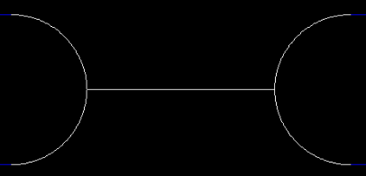
Use this menu to measure the distance between two vectors in the current work window area. Select the desired two vectors after clicking Measure Object menu to activate the shortest distance and indicate the measurement in the output bar.

3-3. Measure Angle
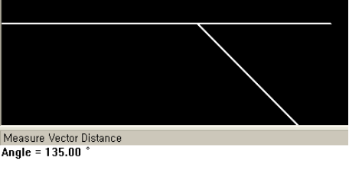
Use this menu to measure the angle between two vectors in the current work window area. Select the desired two vectors after clicking Measure Angle to indicate the measurement in the output bar.

3-4. Query Object
Use this menu to see the detailed attributes (size, types of data, chalk, etc.) in the current work window. Select the desired object after clicking the Query Object menu to indicate the detailed attributes in the output bar.

Mode | Group Select Mode | Vector Select Mode
Gerber | 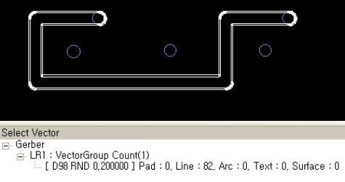
Router | 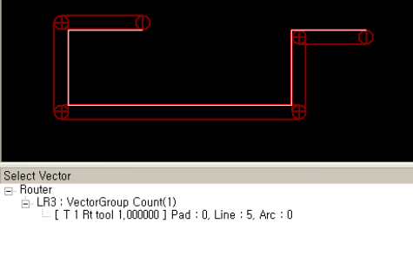 | 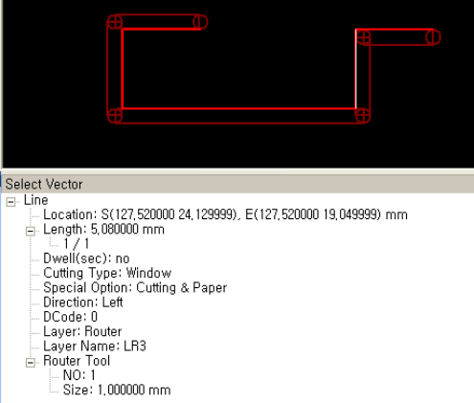

4. Select

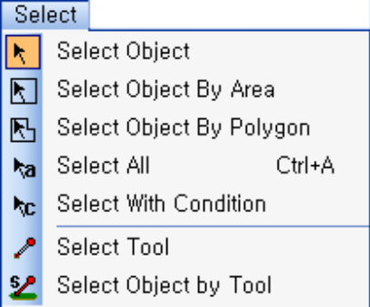 | Select Object
 | Select one object at one mouse click.
 | Select Object By Area
 | Select objects by rectangular area.
 | Select Object By Polygon
 | Select objects by polygonal area.
 | Select All
 | Select all objects on the screen.
 | Select With Condition
 | Select objects conforming to the given condition.
 | Select Tool
 | Select the chalk used by the selected object(aperture, drill tool, Router tool).
 | Select Object by Tool
 | Select the object with the identical chalk (aperture) used by the selected object.

These menus are used in editing by selecting objects. Various combinations of keys are available to select objects as follows.

Mouse Left Click | Free all previous selections and select data. (Selection)
“Ctrl” | Free the previously selected data, and select data which have not been selected. (Reversal)
“Shift” | Add the selected data to the previously selected data. (Addition)
“Ctrl” + “Shift” | Exclude the selected data from the new selection. (Exclusion)

In selection by area, various forms are available as follows.
Inclusion | Include data in the interior of the selected area.
Inclusion and contact | Include data in the selected area and in contact with the selected area.
Contact | Include data in contact with the selected area only.
Exterior | Include data in the exterior of the selected area.
Exterior and Contact | Include data outside the selected area and in contact with the selected area.

4-1. Select Object
Use this menu to select an object from the horizontal layer in the current work window area. The selected object hereby is in the active physical layer. However, if you set many layers except the active layers among the physical layers in the layer window as affective layers, select an object from each affective layer. Therefore, in view of vertical layer concept, plural objects can be selected. Click the Select Object menu (Cursor is switched to Select Object mode by this activity), move the cursor to the desired object, and click on the left mouse button to see the detailed statistic data of the searched objects (number of selected objects, etc.) in the Select Vector tab(when the objects are vectors) of the window.

4-2. Select Object By Area
Use this menu to select objects from the horizontal layer in the current work window area. The function is the same as that of Select Object menu except that plural objects can be selected and mouse use is different. Click on the left mouse button on the desired point, and click on the left mouse button again after moving the cursor to another desired point to select the objects in the rectangular area drawn by the mouse, highlighting them. If you want to change the selection method, set the selection mode of the standard tool bar to another and select the area.

4-3. Select Object By Polygon
Use this menu to select objects from the horizontal layer in the current work window area. The function is the same as that of Select Object menu except that plural objects can be selected and mouse use is different. Click on the left mouse button on the desired point, and click on the left mouse button again after moving the cursor to another desired point to select the objects in the polygonal area drawn by the mouse, highlighting them. If you want to change the selection method, set the selection mode of the standard tool bar to another and select the area.

4-4. Select All
Use this menu to select all objects. No mouse use is necessary. Select Select All menu to select all objects on the screen.

4-5. Select Object By Condition
Use this menu to select desired objects by the attributes that objects have, apart from the methods above. If you select Select Object By Condition menu, <Search With Condition> dialog box will pop up for the searching conditions to be entered.

Search By Condition Dialog box(Gerber)
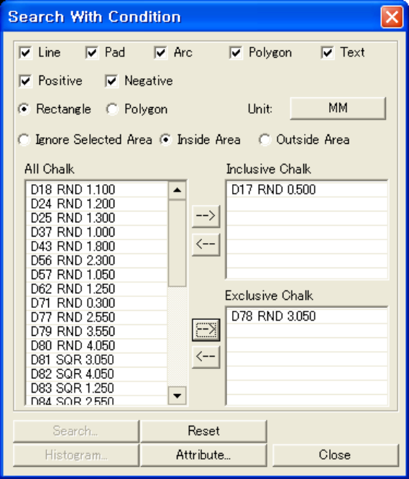
Type(Line, Pad, Arc, Polygon, Text)
These check boxes are controls to select the type of vectors to be searched, and plural selection is possible. If all boxes are checked, all vector data are to be searched.
Polarity(Paint, Scratch)
These check boxes are controls to select the polarity of vectors to be searched, and plural selection is possible. If all boxes are checked, all vector data are to be searched.
Selection Type(Rectangle, Polygon)
This option allows you to select the type of selection area between rectangle and polygon.
Area (Ignore selected area, Inside area, Outside area)
- Ignore Selected Area
Select searching condition on the whole area in spite of any selection by user.
- Inside Area
Select searching condition on the data in the selected area.
- Outside Area
Select searching condition on the data in the unselected area.
Inclusive Chalk, Exclusive Chalk(→, ←)
- Inclusive Chalk
Select searching condition on the data which uses the desired chalk.
- Exclusive Chalk
Select searching condition on the data except what use a chalk which the user wants to ignore.
Search..
This is deactivated because this can be selected as soon as an executable control searching the data corresponding to the condition options or current area is selected after setting up all the condition options.
Reset
Initialize the inclusive chalk list controls and exclusive chalk list controls.
Histogram..
Not working now.
Attribute..
Select data by the additional condition, for example, when the attribute such as .nomenclature or .smd is set.

Search By Condition Dialog box(Router)
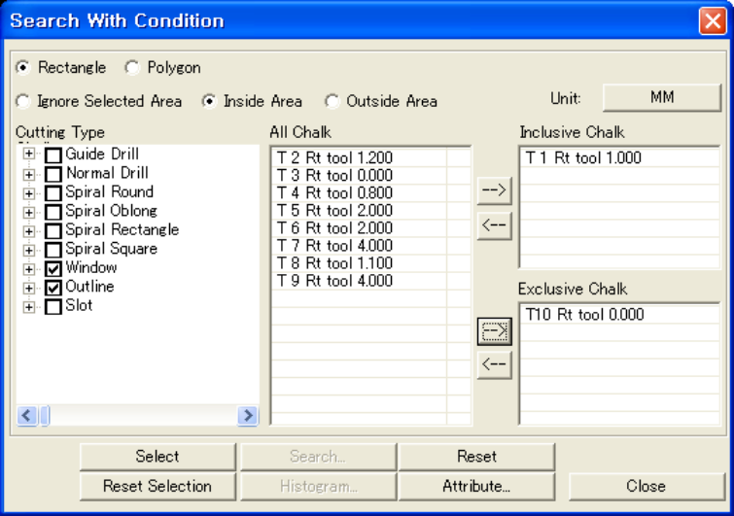
Selection Type(Rectangle, Polygon)
This option allows you to select the type of selection area between rectangle and polygon.
Area (Ignore selected area, Inside area, Outside area)
- Ignore Selected Area
Select searching condition on the whole area in spite of any selection by user.
- Inside Area
Select searching condition on the data in the selected area.
- Outside Area
Select searching condition on the data in the unselected area.

Cutting Type Chalk
The desired cutting type is checked in selecting by cutting type and chalk type on the list.
Inclusive Chalk, Exclusive Chalk(→, ←)
- Inclusive Chalk
Select searching condition on the data which uses the desired chalk.
- Exclusive Chalk
Select searching condition on the data except what use a chalk which the user wants to ignore.
Select
Select using the cutting type checked according to the area options and inclusive or exclusive chalk in the selected area.
Reset Selection
Reset the selected vectors.
Search..
This is deactivated because this can be selected as soon as an executable control searching the data corresponding to the condition options or current area is selected after setting up all the condition options above.
Reset
Initialize the inclusive chalk list controls and exclusive chalk list controls.
Histogram..
Not working now.
Attribute..
Select data by the additional condition, for example, when the attribute such as .nomenclature or .smd is set.

4-6. Select Tool
Use this menu to select the chalk to use through the objects existing in the work window area. Most of users use combo box of the chalk bar to select the current chalk, but this menu finds the chalk which the object has used, and sets the chalk as current chalk. This is a kind of a dropper function. If you select an object after clicking the chalk selection, the chalk used by the selected object will be shown in the combo box of the chalk bar, and will be instantly selected.

4-7. Select Object By Tool
Use this menu to recognize the chalks used by existing objects in the work window area, and select all the objects which use an identical chalk.
If you select a menu, and a vector, all the vectors which use the identical tool are selected.

5. Buffer

Undo
Restore the previous work condition.
Redo
Perform the next work.
Remove Buffer
Remove all contents of buffer.

5-1. Undo
This restores the previous condition before the last work. Undo is performed only to the work relating to vector data. It does not work on the work relating to the layer.

5-2. Redo
Perform the next work. Redo is performed only to the work relating to vector data. It does not work on the work relating to the layer.

5-3. Remove Buffer
Remove all contents of buffer. When all contents of buffer are removed, no more Redo and Undo can be performed. The current buffer condition is shown in the Condition Bar under the screen.

6. Edit(Gerber)

Delete ▶
Delete the selected object.
Copy ▶
Copy the selected object.
Move ▶
Move the selected object.
TransForm
Adjust the rotation, reflection, scale of the selected object.
Chain ▶
Group or ungroup the selected objects.
Change ▶
Change the attributes of the selected object.
Reshape ▶
Change the shape of the selected object.

6-1. Delete ▶

Delete Vector
Delete the selected object.

6-1-1. Delete Vector
Use this menu to delete the previously selected object or to click this menu and select the objects to be deleted.

6-2. Copy ▶

Copy To Different Layer
Copy the selected object to another layer.
This menu copies the selected objects to another layer. However, the location follows the coordinate of the original object.

Copy To Different Layer
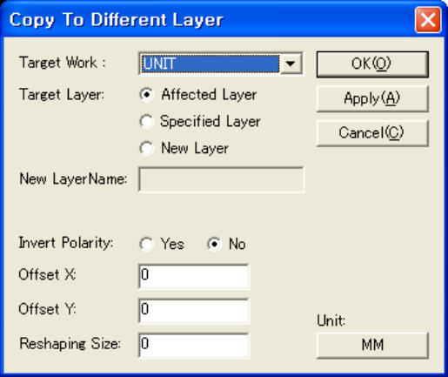
Target Work
Select the work the selected object are copied to.
Target Layer
- Affected Layer
– Copy the original object to the affected layer of the target work.
- Specified Layer
– Copy the original object to a selected layer among the layers of the target work.
- New Layer
– Copy the original object to a newly created layer of the target work.
New Layer Name
Determine a new layer name created by selecting New Layer at the target layer.
Layer Name
Select the layer to be copied in selecting specified layer at the target layer.
Invert Polarity
Copy the polarity of the object as inverted in copying an object.
Offset X, Offset Y
Copy the object with the transfer of the offset value entered by the user from the coordinate of original objects.

Reshaping Size
Copy the objects after changing the size entered by the user.

6-3. Move ▶
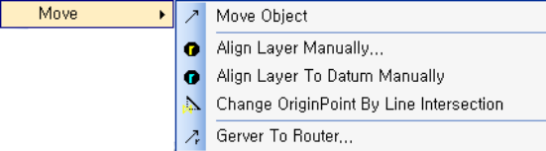 |  | Move Object
 |  | Move the coordinate of an object.
 |  | Align Layer Manually..
 |  | Move all the objects according to the offset.
 |  | Align Layer To Datum Manually
 |  | Set the coordinate of selected object to the datum coordinate and move the other objects by the same offset.
 |  | Change Origin Point By Line Intersection
 |  | Move the origin to the intersection of the selected two lines.
 |  | Gerber To Router..
 |  | Transform the Gerber data to Router data.

6-3-1. Move Object
Use this menu to select an object and change the coordinate of the object in the identical layer. Select the reference point on the selected object and press “F” key after clicking the destination with the mouse.
The object can be moved by direct input of coordinate value.

6-3-2. Align Layer Manually..

Align Layer Manually Dialog Box
Layer List
This is a layer list of the current active work. Apply Layer can be checked with ‘V’, and manual layer alignment is performed on the checked layer.
All Select
All layers in the layer list are checked.
All Unselect
All layers in the layer list are unchecked.

6-3-3. Align Layer To Datum Manually
Use this menu to align a layer to datum. Click the menu, select the specified pad, and the pad will move to the coordinate of the datum, with moving of all objects by the offset.

6-3-4. Change Origin Point By Line Intersection
Select two lines on the screen and set the intersection as the origin of the data. Notice that the coordinates of all data changes if the origin changes.

6-3-5. Gerber To Router..
Use this menu to transform the selected Gerber data to Router layer. Select a vector and click “OK” in the next dialog to transform it into the Router data according to the designated attributes.

Gerber To Router
Flash ▶ Tool Num.
Specify the Tool Number into which flash data are transformed.
Flash ▶ Cutting
Specify the processing type with which flash data are transformed.
Vector ▶ Tool Num.
Specify the Tool Number into which vector data are transformed.
Vector ▶ Cutting
Specify the processing type with which vector data are transformed.
Vector ▶ Compensation
Specify the compensation of the transformed vector data.
- Left: Left compensation
- None: No compensation
- Right: Right compensation
Target Layer
Specify a router layer for the layer to be transformed into.

6-4. Transform
Use this menu to transform the selected object.

Transform Dialog
Target Layer
- Affected Layer
– Copy the original objects to the affected layer of the target work.
- Specified Layer
– Copy the original objects to a selected layer among the layers of the target work.
- New Layer
– Copy the original objects to a newly created layer of the target work.
Layer Name
Select the layer to be copied in selecting specified layer at the target layer.
New Layer Name
Determine a new layer name created by selecting New Layer at the target layer.
Anchor
This is a referential coordinate in rotation and reflection. Click on the desired point or anchor button to see the center of the smallest area containing the selected data.

Operation
- Rotation
Check for a rotation.
- Mirror
Check for a Mirror action.
- Scale
Check for enlarging or shrinking objects.
Angle
Specify the angle in rotation of the selected object.
Scale
Enter the enlargement ratio or reduction ratio of the selected object.
Keep Original
- In case of keeping the original
Copy the original to which transformation options are applied.
- In case of not keeping original
Transformation options are applied to the selected object.
Mode
Transformation by each selected object or by one reference point is determined and checked.
Offset
Move the data transformed by the anchor value, by the offset distance in the current coordinate.

6-5. Chain ▶

Chain
Group the selected objects.
Unchain
Ungroup the selected objects.

6-5-1. Chain
Use this menu to group the connected objects with selected objects.
1. Select the vectors, and the menu, to group the selected objects.
2. Select the menu, and click the objects one by one, to group the vectors connected at both ends.

Before | After

6-5-2. Unchain
Use this menu to ungroup the grouped objects among the selected objects.
Select the vectors to ungroup and select the menu.

Before | After

6-6. Reshape ▶

Sectorize Arc..
Sectorize an arc into plural lines.
Desectorize Arc..
Restore plural lines into an arc.

6-6-1. Sectorize Arc..
Use this menu to sectorize the selected arc object into plural line objects. Sectorizing can be performed by the number of lines, the lengths of lines, minor and major arc distances.

Before | After
 | 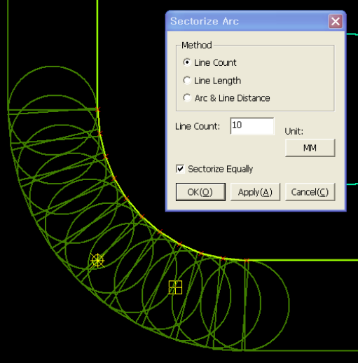

Sectorize Arc Dialog Box
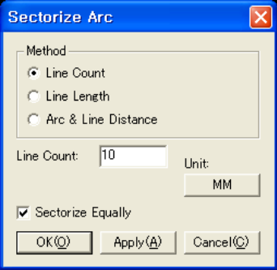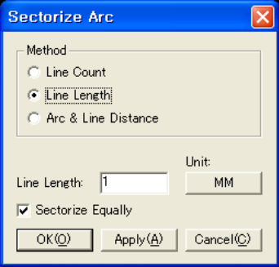
Method
- Line Count
- When sectorizing by the desired number of lines.
- Line Length
- When sectorizing by the desired lengths of lines.
- Arc and Line Distance
When sectorizing by Arc and Line Distance.
Line Count
Enter the number of lines in sectorizing by the number of desired number of lines.
Line Length
Enter the lengths of lines in sectorizing by the lengths of desired number of lines.
Sectorize equally
Select in sectorizing by the equal lengths of lines. The length can differ from the length entered in sectorizing by the lengths of lines.

6-6-2. DeSectorize..
Use this menu to replace plural lines with an arc. This is performed by the condition of the number of segments, the angle between lines, and the tolerance.

DeSectorize Arc Option Dialog Box
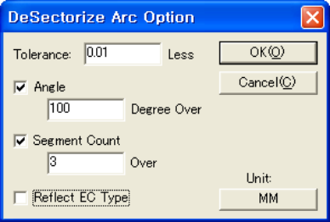
Tolerance
Specify the tolerance to make an arc with plural lines.
Segment Count
Specify the minimum number of segments to make an arc.
Angle
Specify the allowable angle of the adjacent segment.
Reflect EC Type
Specify the consideration of Etching Type attribute in making an arc. (It means nothing in Router work.)

7. Edit(Router)

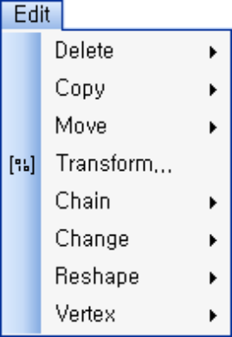 | Delete ▶
 | Delete the selected object.
 | Copy ▶
 | Copy the selected object.
 | Move ▶
 | Move the selected object.
 | Transform
 | Adjust the rotation, reflection, and scale of the selected object.
 | Chain
 | Group or ungroup the selected objects.
 | Change ▶
 | Change the selected object.
 | Reshape ▶
 | Change the shapes of the object.
 | Vertex
 | Delete or move vertex.

7-1. Delete

Delete Vector
Delete the selected object.

7-1-1. Delete
Use this menu to delete the previously selected object or to click this menu and select the object to be deleted.

7-2. Copy ▶

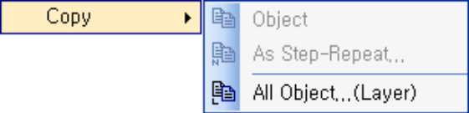 | Object
 | Copy an object to the identical layer.
 | As Step-Repeat..
 | Copy an object to the identical layer as step-repeat.
 | All Object.. (Layer)
 | Copy objects to the identical layer or to a different layer.

7-2-1. Object
Use this menu to copy the selected objects or select objects to copy to the desired location on the identical layer.

7-2-2. As Step-Repeat..
Use this menu to copy the selected object as step-repeat and insert.

Copy As Step-Repeat
Step-Repeat Type
This is an option to determine the copy type.
- Matrix
- Copy in grid shape with the step-repeat value as the reference.
- Oblique
- Copy in oblique shape with the quantity as the reference.
Parameter(Step-Repeat)
Enter the repeat values to copy the selected vector as step-repeat for grid type.
Parameter(Quantity)
Enter the quantity to copy for oblique type.
Parameter(Distance)
Enter the distance between the objects to copy.

7-2-3. All Object..(Layer)
Use this menu to copy the objects on the specific layer to the identical layer or a different layer. The menu is activated only when no object is selected.

Copy Router Layer Dialog Box
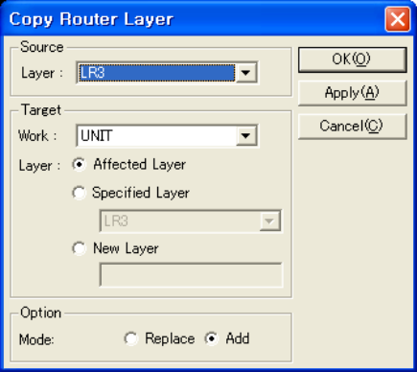
Source Layer
Select the layer to copy.
Target Work
Select the work which the selected objects are copied to.
Target Layer
- Affected Layer
– Copy the original object to the affected layer of the target work.
- Specified Layer
– Copy the original object to a selected layer among the layers of the target work.
- New Layer
– Copy the original object to a newly created layer of the target work.
Layer Name
Select the layer to be copied in selecting specified layer at the target layer.
New Layer Name
Determine a new layer name created by selecting New Layer at the target layer.
Mode
This is an option for data process of the layer to copy.
- Replace
- Remove all objects on the layer to copy.
- Add
- Keep the objects on the layer to copy.

7-3. Move ▶

Object
Move the coordinate of an object.
Align Layer Manually..
Move all objects according to the offset.
Align Layer To Datum Manually
Set the coordinate of selected object to the datum coordinate and move the other objects by the same offset.

7-3-1. Object
The same as Gerber edit function. (Refer to 6-3-1)

7-3-2. Align Layer Manually..
The same as Gerber edit function. (Refer to 6-3-2)

7-3-3. Align Layer To Datum Manually
The same as Gerber edit function. (Refer to 6-3-3)

7-4. Transform
The same as Gerber edit function. (Refer to 6-4)

7-5. Chain ▶

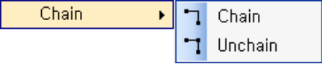 | Chain
 | Group the selected objects.
 | Unchain
 | Ungroup the selected objects.

7-5-1. Chain
The same as Gerber edit function. (Refer to 6-5-1)

7-5-2. Unchain
The same as Gerber edit function. (Refer to 6-5-2)

7-6. Change ▶

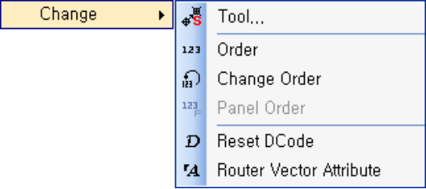 | Tool..
 | Change the tool for the selected object.
 | Order
 | Specify the order of vector processing again.
 | Change Order
 | Change the order of vector processing.
 | Panel Order
 | Specify the order of panel processing again.
 | Reset Dcode
 | Initialize Dcode.
 | Router Vector Attribute
 | Change the attributes of Router vector.

7-6-1. Tool..
Use this menu to change the tool of a vector.

Change Tool Dialog
Chalk
Click to select a new tool.

Chalk Dialog
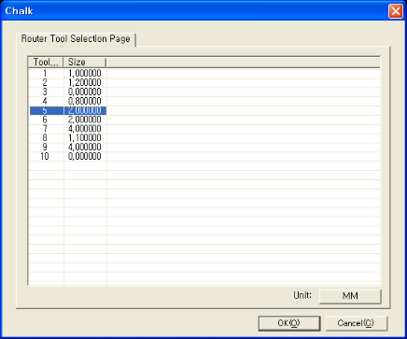
This displays Router tool list of the current active work to select a tool.
Click OK to apply the selected tool in the Reshape Tool Dialog.

7-6-2. Order
Use this menu to specify the order.
Order specification can be performed by group.

Set Ordering Dialog
Ordering Method
Select an ordering method.
- Continuous
- This is selected to set all Dcodes after the first value again.
- Sequence
- Change two selected Dcodes and rearrange the Dcodes between them.
Value
In case of Continuous, enter the first value.
In case of Sequence, enter the two values.

7-6-3. Change Order
Use this menu to change the order of two.
Select two groups to change the mutual order.

7-6-4. Panel Order

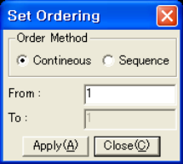
This menu is activated when there is step-repeated work.
Use this menu to specify the order of step-repeated works. The works are arranged in the selected order.

7-6-5. Reset Dcode
Use this menu to initialize the Dcode.

7-6-6. Router Vector Attribute
Use this menu to change the attributes of the Router vector group.
Select a menu, and the vector group to be changed.

Change Attributes Dialog
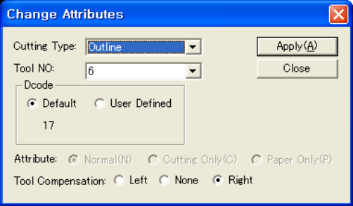
Cutting Type
Select attributes such as Outline/Window/Slot/Guide Drill/Spiral.
Tool NO
Select tool No. among 1~10.
DCode
Set Dcode.
- Default
- Set as default
- User Defined
- Enter the value for Dcode.
Attribute
Specify the attributes of Router vector group.
- Normal
- For both cutting and drawing.
- Cutting Only
- For cutting only
- Paper Only
- For drawing only.
Tool Compensation
Specify tool compensation.
- Left
- Left compensation
- None
- No compensation
- Right
- Right compensation

7-7. Reshape ▶

Change Direction
Change direction of a group.
Sectorize Arc..
Sectorize an arc.
Desectorize Arc..
Restore plural lines into an arc.
Change Arc Direction
Change the direction of an arc.
Chamfer
Cut an edge.
Link Line
Link two lines.
Attach Line
Attach a line to another.
Break
Find an intersection with the selected vector and break.

7-7-1. Change Direction
Use this menu to change the direction of selected vector group.
Select the menu, and the object, and press “F” key to change direction.

7-7-2. Sectorize Arc..
The same as Gerber edit function. (Refer to 6-7-1)

7-7-3. Desectorize Arc..
The same as Gerber edit function. (Refer to 6-7-2)

7-7-4. Change Arc Direction
Use this menu to change the direction of selected arc.
Select the object first, and the menu, to reverse the direction of the arc.

7-7-5. Chamfer
Use this menu to cut the edge.
Objects for the Chamfer must be in the same group.
Select the menu, set the value of Corner Cut Dialog, select two adjacent lines or arcs, and press “F” key.

Before | Corner Cut With Line | Corner Cut With Arc
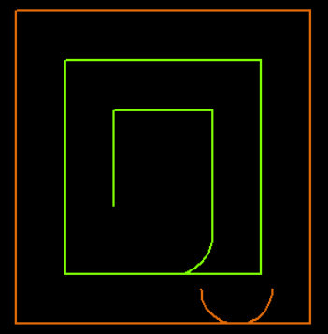 |  | 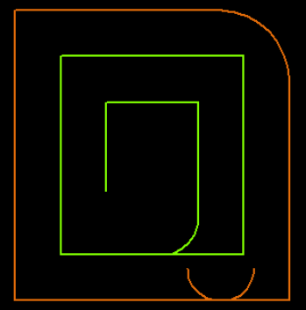

Corner Cut Dialog
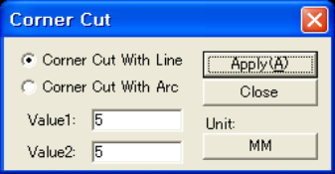
Method
Specify the type of Corner Cut.
- Corner Cut With Line
- Cut with an angle
- Corner Cut With Arc
- Cut in the shape of an arc.
Value
Enter the values. Two values for Corner Cut With Line, and 1 value for Corner Cut With Arc.

7-7-6. Link Line
Use this menu to connect the ends of two lines.
Select the menu, and the two lines, and click on the left mouse button on the vicinity of connection to connect the lines.
Before | After
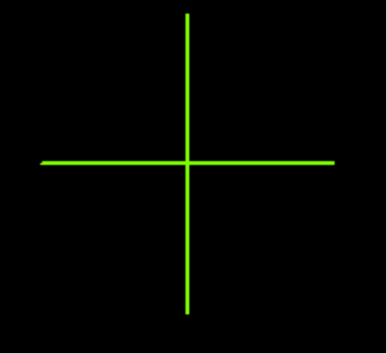 | 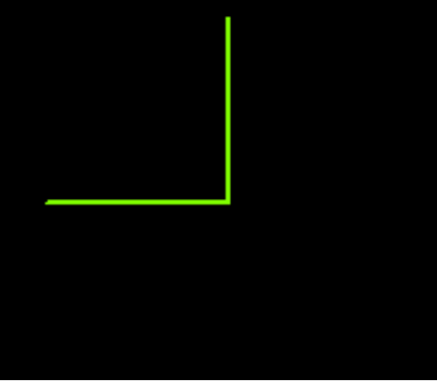

7-7-7. Attach
Use this menu to extend a line to connect to another line.
Select the menu, and the line to be extended, and the line to be connected to.
Click on the left mouse button in the extending direction to connect the lines. However, there will be no change if the extended line does not meet another.

Before | After
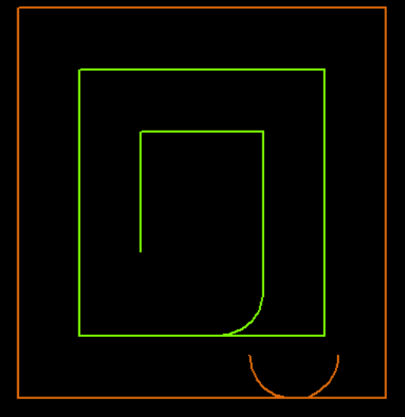 | 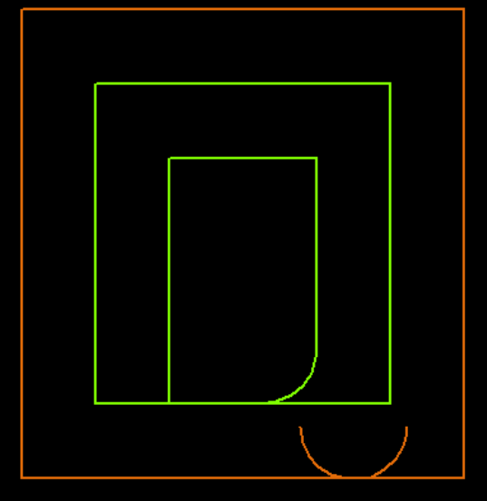

7-7-8. Break
Use this menu to find intersections of the selected vectors to break them.
Select the vector, and the menu. The group is maintained in spite of breaking.

Before | After
 | 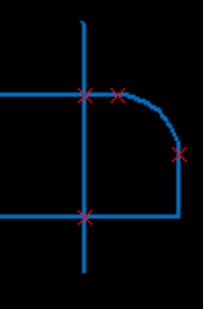

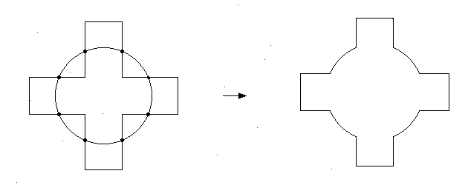

7-8. Vertex ▶

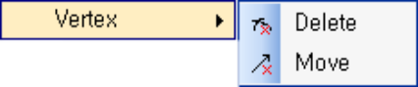 | Delete
 | Delete vertex.
 | Move
 | Move vertex.

7-8-1. Delete
Use this menu to delete one vertex.
Select the menu, and select the vertex to be deleted.

7-8-2. Move
Use this menu to move one vertex.
Select the menu, and the desired vertex, and move to the destination point.
Press “F” key.

8. Edit(Popcopy)

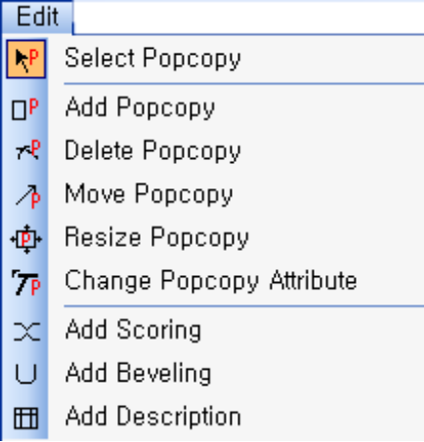 | Select Popcopy
 | Select a popcopy.
 | Add Popcopy
 | Add a popcopy.
 | Delete Popcopy
 | Delete a popcopy.
 | Move Popcopy
 | Move a popcopy.
 | Resize Popcopy
 | Change the size of a popcopy.
 | Change Popcopy Attribute
 | Change the attributes of a popcopy.
 | Add Scoring
 | Register and save scoring or get the registered scoring.
 | Add Beveling
 | Register and save Beveling or get the registered Beveling.
 | Add Description
 | Register and save description or get the registered description.

8-1. Select popcopy
Use this menu to select a popcopy.

8-2. Add popcopy
Use this menu to add a popcopy. Click on the left mouse button on the desired point, and click on the left mouse button again after moving the cursor to a destination point to add the rectangular area drawn by the mouse.

8-3. Delete popcopy
Use this menu to delete a popcopy. Working for both selected popcopies and unselected popcopies.

When popcopy has been selected | Delete the selected popcopy.
When popcopy has not been selected | Select the popcopy to delete. The selected popcopy is deleted.

8-4. Move popcopy
Use this menu to move a popcopy. Working for both selected popcopies and unselected popcopies.

When popcopy has been selected | Move the selected popcopy. If you select two points on the screen, the popcopy is moved at the distance between the points.
When popcopy has not been selected | Select a popcopy to move.. If you select two points on the screen, the popcopy is moved at the distance between the points.

Use this menu to change the size of a popcopy. Click on the edge of the popcopy to resize, to enlarge or shrink it to desired size.

8-5. Resize popcopy

8-6. Change popcopy attribute
Use this menu to change the attributes of a popcopy (name, layer). Working for both selected popcopies and unselected popcopies.

When popcopy has been selected | <Popcopy> Dialog Box pops up as follows.
When popcopy has not been selected | If you select the popcopy to change, <Popcopy> Dialog Box pops up as follows.

Popcopy Dialog
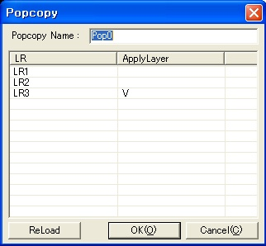

Popcopy name
Enter the name of a newly created popcopy.
Layer list
Select layers to apply to the popcopy.
Reload
This is a button to apply the new layer setting when the layer structure changes in creating popcopies.
This menu is effective for Change Popcopy menu rather than Add Popcopy menu.

8-7. Add scoring..
Use this menu to register or change a scoring for the work. Registered scorings can be saved as files for a library. If you select <Add scoring..>, <Scoring> Dialog Box will pop up.

Scoring dialog
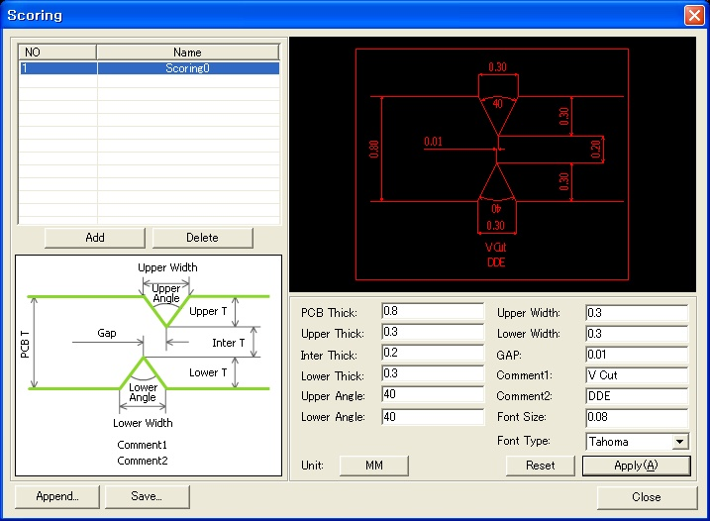
Scoring list
This displays the list of registered scorings. Click on the scoring to change.
Scoring image
Exemplary drawing for the reference to enter dimensions.
Append..
Get the previously saved scorings and add them to the end of the list.
Save..
Save the current scoring list on a file.
Preview
Preview the shape by the selected scorings. Change it to desired shape by altering the fonts and shapes. Scoring Preview displays the shape on the screen at the real dimension ratio.
Scoring Values
With reference to the left figure, enter the data of dimensions.
Font size
Enter the font size to use in the dimension line.
Font type
Enter the font type to use in the dimension line.
Font types can be set in the <Drawing> of <Option> Dialog Box.
Reset
Initialize all entered values.
Apply
Preview in which the entered dimensions are applied to the selected scoring.

8-8. Add beveling..
Use this menu to register or change a beveling for the work. Registered bevelings can be saved as files for a library. If you select <Add Beveling..>, <Beveling> Dialog Box will pop up as follows.

Beveling dialog
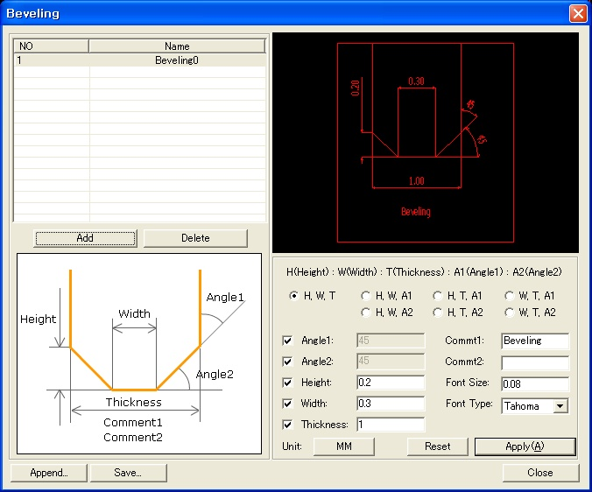
Beveling List
This displays the list of registered bevelings. 변경하길 원하는 베벨링을 클릭하세요.
Beveling Image
Exemplary drawing for the reference to enter dimensions.
Add..
Get the previously saved bevelings and add them to the end of the list.
Save..
Save the current beveling list on a file.
Beveling Preview
Preview the shape by the selected bevelings. Change it to desired shape by altering the fonts and shapes. Beveling Preview shows the shape on the screen at the real dimension ratio.
Beveling Entering Type
Select a method to enter values. 7 methods are available.
- Height(H), Width(W), Thickness(T)
- Height(H), Width(W), Angle1(A1)
- Height(H), Width(W), Angle2(A2)
- Height(H), Thickness(T), Angle1(A1)
- Height(H), Thickness(T), Angle2(A2)
- Width(W), Thickness(T), Angle1(A1)
- Width(W), Thickness(T), Angle2(A2)
Beveling Value
With reference to the left figure, enter the data of dimensions. According to the values entered, only the controls conforming to the values are activated. The rest of values are automatically calculated.
Font Size
Enter the font size to use in the dimension line.
Font Type
Enter the font type to use in the dimension line.
Font types can be set in the <Drawing> of <Option> Dialog Box.
Reset
Initialize all entered values.
Apply
Preview in which the entered dimensions are applied to the selected beveling.

8-9. Add description..
Use this menu to register or change a description for the work. Registered descriptions can be saved as files for a library. If you select <Add Description..>, <Description> Dialog Box will pop up as follows.

Description dialog
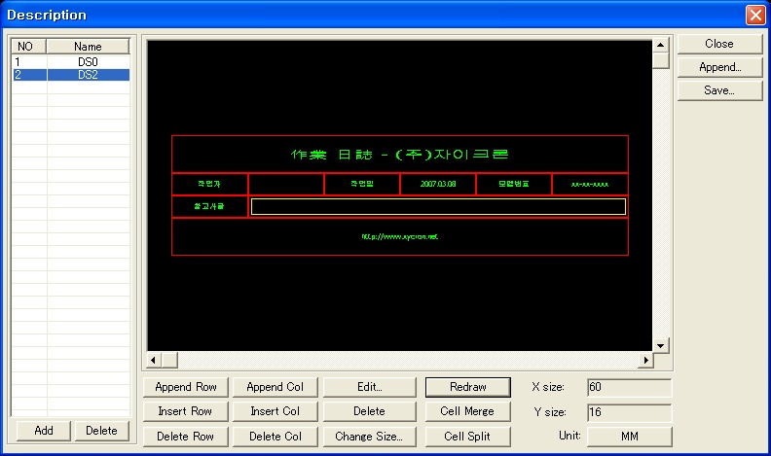
Description List
This displays the list of registered descriptions.
Click on the description to change to see the related information.
Append..
Get the previously saved descriptions and add them to the end of the list.
Save..
Save the current description list on a file.
Description Preview
Preview the shape by the selected descriptions. The cell to be changed can be selected by a mouse click. Select cells to merge with the mouse to merge the cells.
Row Command
- Append Row: Append a new row as the last row.
- Insert Row: Insert a new row over the selected row.
- Delete Row: Delete the selected row.
Column Command
- Append Col.: Append a new column as the last column.
- Insert Col.: Insert a new column on the left of the selected column.
- Delete Col.: Delete the selected column.
Cell Command
- Edit..
- Change the contents of a cell. If you click <Edit..>, <Cell Editing> dialog box will pop up.
– Refer to the <Cell Editing> Dialog Box as follows.
- Cell Merge: Merge the selected cells.
- Cell Split: Split a merged cell into the original cells.
- Delete: Delete all contents in a cell.
- Change Size..: Note that a merged cell cannot be resized.
– If you click <Change Size..>, <Size> Dialog Box will pop up.

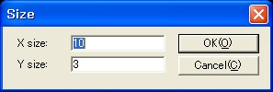

Redraw
Redraw the preview by the changed setting.

Cell editing
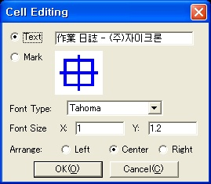
Cell Type
Determine the indication type between the text and mark.
Click on the image for the mark to change the shape of mark.
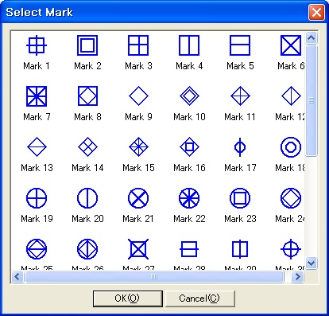
Font Type
Specify the type of text font.
Font Size
Specify the font size.
Arrange
Specify the arrangement method of the text shown in the cell.

9. Edit(Dimension)

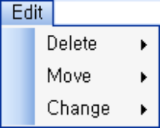 | Delete
 | Delete the selected dimension line.
 | Move
 | Move the text location of the selected dimension line.
 | Change
 | Change the contents of the selected dimension line.

9-1. Delete

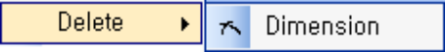 | Dimension
 | Delete the selected dimension line.
When the dimension line is already selected, the selected dimension line is deleted. Select the dimension line if it is not selected.

9-2. Move

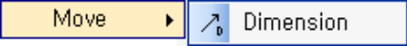 | Dimension
 | Move the selected dimension line.
When the dimension line is already selected, the selected dimension line can be moved. It can be moved by the distance between two points The dimension line does not move, but the location of the text moves.

9-3. Change

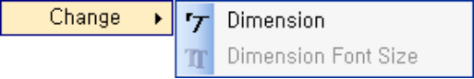 | Dimension
 | Change the contents of the selected dimension line.

9-3-1. Change Dimension
Use this menu to change the contents of dimension line. When the dimension line to be changed is selected, <Dimension Data> Dialog Box pops up as follows.

DIMENSION DATA Dialog
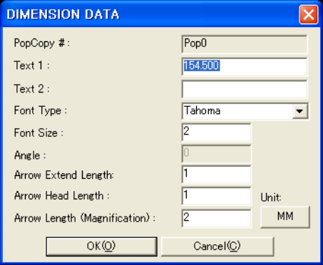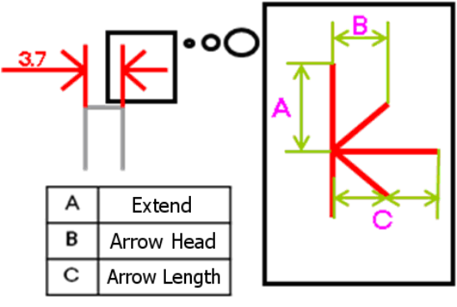
PopCopy #
This displays the number of popcopy the dimension line belongs to. Unchangeable.
Text 1
This displays the information of the text above the dimension line.
Text 2
This displays the information of the text below the dimension line.
Font Type
This displays the font type specified to the dimension line.
Font Size
This displays the font size specified to the dimension line.
Angle
This show the angle for the dimension line.
Arrow Extend Length
Refer to the figure above.
Arrow Head Length
Refer to the figure above.
Arrow Length(Magnification)
Refer to the figure above. Enter according to the ratio of the arrowhead length

9-3-2. Dimension Font Size
Revise the font size of more than one dimension.
Select the vector, and the menu.

10. Edit(Layout)

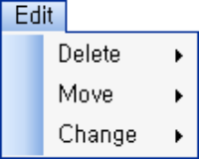 | Delete
 | Delete a layout item.
 | Move
 | Move a layout item.
 | Change
 | Change a layout item.

10-1. Delete Layout ▶

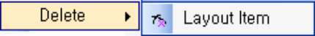 | Layout Item
 | Delete a layout item.
Use this menu to delete the previously selected object or to click this menu and select the layout items to be deleted.

10-2. Move Layout ▶

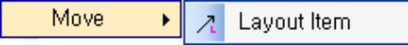 | Layout Item
 | Move a layout item.
Use this menu to move selected plural layout items. This menu can work to select an item when no layout items are selected. Select one layout in selecting by menu.

10-3. Change ▶
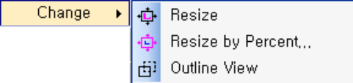 | Resize
 | Change the size of a layout item.
 | Resize by percent..
 | Change the size of a layout item by percent.
 | Outline View
 | Specify the Outline View of a layout item.

10-3-1. Resize
Use this menu to adjust the size of selected layout and layout item by this menu.

10-3-2. Resize by Percent..
Use this menu to change the size of layout items at the ratio of current size or original size on the selected plural layout items.

Resize Layout Item Dialog Box
Standard Scale(Original)
This is an option to apply the ratio of the original.
Standard Scale(Current)
This is an option to apply the ratio of the current.
Times
Enter the number by which the selected standard is multiplied.

10-3-3. Ouline View
Use this menu to toggle the appearance of the outline of selected layout items.

ON | OFF
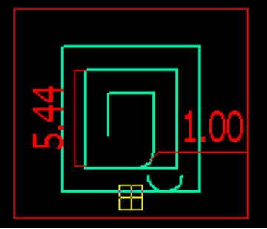 | 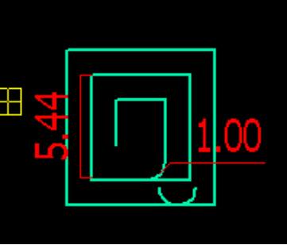

11. Add

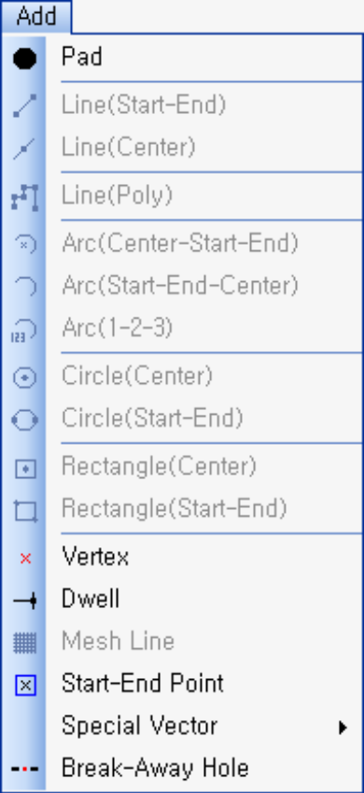 | Pad
 | Add a Pad.
 | Line (Start-End)
 | Add a line with a start point and end point.
 | Line(Center)
 | Add a line with a center point and length.
 | Line(Poly)
 | Add a multiple line or an arc.
 | Arc(Center-Start-End)
 | Add an arc with a center, a start, and an end.
 | Arc(Start-End-Center)
 | Add an arc with a start, an end, and a center.
 | Arc(1-2-3)
 | Add an arc with a start, an end, and a point on a circle.
 | Circle(Center)
 | Add a line with a center and a radius.
 | Circle(Start-End)
 | Add a line with a start point and an end point.
 | Rectangle(Center)
 | Add a rectangle with a center and the length of width and height.
 | Rectangle(Start-End)
 | Add a rectangle with an upper left point and a right lower point.
 | Vectex
 | Add a vertex.
 | Dwell
 | Specify a Dwell.
 | Mesh Line
 | Add a Mesh Line.
 | Start-End Point
 | Add a Start point and an End point.
 | Special Vector ▶
 | Add a Special Vector.
 | Break Away Hole
 | Add a Break Away Hole.

11-1. Pad
Use this menu to add a pad. Attributes Dialog Box differs according to the type, and the corresponding value must be entered.

Add Drill Dialog
Repeat
When a drill is added by step-repeat, the value must be entered.
Distance
Enter the distance between the added pads in case of adding by step-repeat.

Add Spiral Round Dialog
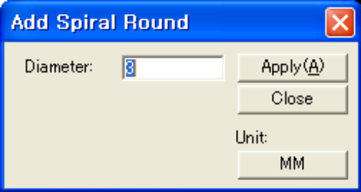
Diameter
Enter the diameter in adding a circle to be spirally processed. The value must be more than 2 times the tool size.

Add Spiral Square Dialog
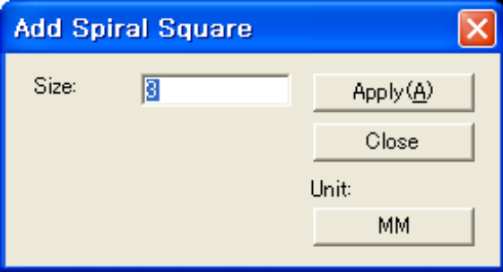
Size
Enter the size in adding a rectangle to be spirally processed. The value must be more than 2 times the tool size.

Add Spiral Rectangle Dialog
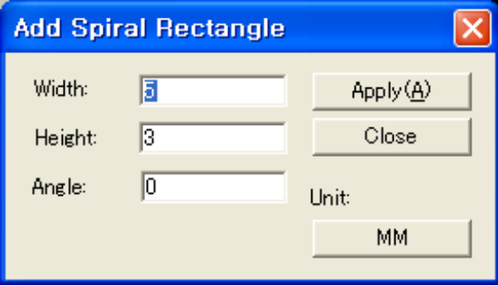
Width
Enter the width in adding a rectangle to be spirally processed. The value must be more than 2 times the tool size.
Height
Enter the height in adding a rectangle to be spirally processed. The value must be more than 2 times the tool size.
Angle
Enter the rotation angle of the rectangle to be spirally processed.

Add Spiral Oblong Dialog
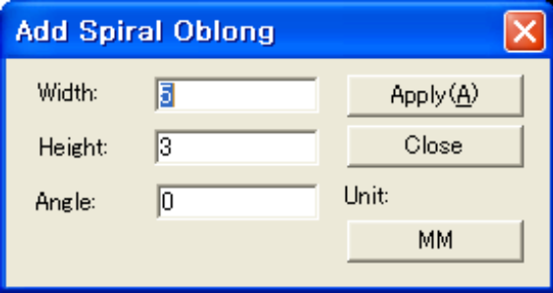
Width
Enter the width in adding an oblong to be spirally processed. The value must be more than 2 times the tool size.
Height
Enter the height in adding an oblong to be spirally processed. The value must be more than 2 times the tool size.
Angle
Enter the rotation angle of the oblong to be spirally processed.

11-2. Line(Start-End)
Use this menu to add a line in the work window area. With this menu, you can draw a line with the specified chalk from the chalk bar in the work window area, and also draw on the affected layer in the layer window. Select a desired chalk in the chalk bar and draw. Select <Add::Line(Start-End)>. Fix the cursor on the desired coordinate in the work window area, click on the left mouse button, create a start and an end, and press F key. Then a line is added.

11-3. Line(Center)
Use this menu to draw a line in the work window area by specifying the coordinate and length. With this menu, you can draw a line with the specified chalk from the chalk bar in the work window area, and also draw on the affected layer in the layer window. Select a desired chalk in the chalk bar and draw. Select <Add::Line(Center)>. < Add::Line(Center) Dialog Box pops up.

Add Line(Center) Dialog
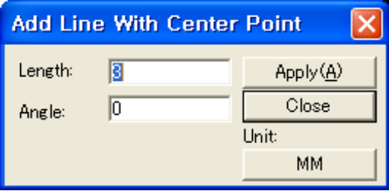
Length
Enter the length of the line to be added.
Angle
Enter the rotation angle of the line to be added.

11-4. Line(Poly)
Use this menu to add a line(multiple) in the work window area. With this menu, you can draw a line(multiple) with the specified chalk from the chalk bar in the work window area, and also draw on the affected layer in the layer window. Multiple line means a line consisting of plural lines. Select a desired chalk in the chalk bar and draw. Select <Add::Line(Poly)>. Move the cursor to the desired coordinate in the work window area, draw the first line, click on the left mouse button, draw another line, and click on the left mouse button. This is how to draw a line. After you draw the line(multiple), click on the left mouse button, and press “E” and “F” in sequence. Then a line(multiple) is added.

11-5. Arc(Center-Start-End)
Use this menu to draw an arc by fixing the center of an arc in the work window area. With this menu, you can draw an arc with the specified chalk from the chalk bar in the work window area, and also draw on the affected layer in the layer window. Select a desired chalk in the chalk bar and draw. Select <Add::Arc(Center-Start-End)>. <Add Arc> Dialog Box pops up.
The direction of rotation is specified as either clockwise or counter-clockwise. Move the cursor to the desired coordinate, click on the left mouse button to mark the center of the arc. Move the cursor again to draw a desired length of an arc. After drawing, click on the left mouse button, and press “F” key. Then an arc is added.

Add Arc Dialog
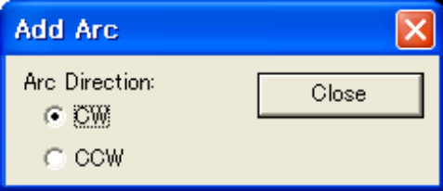
Arc Direction
Specify the direction in add an arc.

11-6. Arc (Start-End-Center)
Use this menu to draw an arc by specifying the start, end, and center of an arc in the work window area. With this menu, you can draw an arc with the specified chalk from the chalk bar in the work window area, and also draw on the affective layer in the layer window. Select a desired chalk in the chalk bar and draw. Select <Add::Arc(Start-End-Center)>. <Add Arc> Dialog Box pops up.
The direction of rotation is specified as either clockwise or counter-clockwise. Move the mouse cursor to the desired coordinate in the work window area, and click on the left mouse button. Then the center of the arc is marked. Move the cursor, click on the left mouse button, to mark the end of the arc. Finally, move the cursor to specify the center of the arc, and click on the left mouse button. After specifying start, end, and center, draw the arc by moving the cursor. Click on the left mouse button, and press “F” key. Then an arc is added.

11-7. Arc(1-2-3)
Use this menu to draw an arc by specifying the start, end, and a point on the circle of an arc in the work window area. With this menu, you can draw an arc with the specified chalk from the chalk bar in the work window area, and also draw on the affective layer in the layer window. Select a desired chalk in the chalk bar and draw. Select <Add::Arc(1-2-3)>. <Add Arc> Dialog Box pops up.
The direction of rotation is specified as either clockwise or counter-clockwise. Move the cursor to the desired coordinate, click on the left mouse button to mark the starting point of the arc. Move the cursor, click on the left mouse button, to mark the end of the arc. Finally, move the cursor to specify the point on the arc, and click on the left mouse button. After specifying start, end, and a point, move the cursor. Then an arc is drawn. Click on the left mouse button, and press F key. Then an arc is added.

11-8. Arc(Center)
Use this menu to draw an arc by specifying the center of an arc in the work window area. With this menu, you can draw with the specified chalk from the chalk bar in the work window area, and also draw on the affective layer in the layer window. Select a desired chalk in the chalk bar and draw. Select <Add::Arc(Center)>. <Add Circle With Center Point> Dialog Box pops up.
Move the cursor to the desired location in the work window area, and click on the left mouse button to specify the center X, and center Y. You can directly enter the values for center X, and center Y. Specify the attributes as follows.
After specifying, click on the Apply button. Then a circle is added.

Add Circle(Center) Dialog
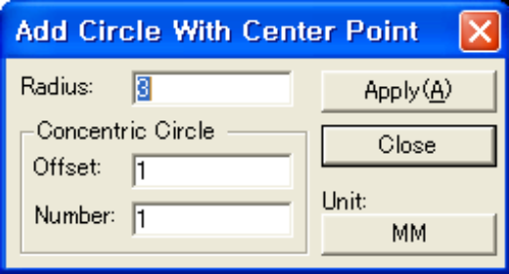
Radius
Specify the radius of the circle to add.
Concentric Circle – Offset
Enter the distance between the concentric circles.
Concentric Circle - Number
Enter the number of concentric circles to add.
Apply
Apply the selected values.

11-9. Circle(Start-End)
Use this menu to draw a circle by specifying the center and end of a circle in the work window area. With this menu, you can draw with the specified chalk from the chalk bar in the work window area, and also draw on the affective layer in the layer window. Select a desired chalk in the chalk bar and draw. Select <Add::Circle(Start-End)>. Move the cursor to the desired location in the work window area, and click on the left mouse button to specify the starting point of the circle. Move the cursor, click on the left mouse button, to mark the end of the circle. Press “F” key. Then a circle is drawn.

11-10. Rectangle(Center)
Use this menu to draw a rectangle in the work window area by specifying center X, center Y, width, and height. With this menu, you can draw a rectangle with the specified chalk from the chalk bar in the work window area, and also draw on the affective layer in the layer window. Select a desired chalk in the chalk bar and draw.
Select <Add::Rectangle(Center)>. <Add Rectangle With Center Point> Dialog Box pops up.
Move the cursor to the desired location in the work window area, and click on the left mouse button to specify the center X, and center Y. You can directly enter the values for center X, and center Y. Specify the attributes as follows.
After specifying, click on the Apply button. Then a rectangle is added.

Add Rectangle(Center) Dialog
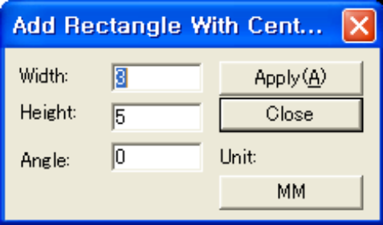
Width
Specify the width of the rectangle to be added.
Height
Specify the height of the rectangle to be added.
Angle
Specify the angle of the rectangle to be added.
Apply
Apply the selected values.

11-11. Rectangle(Start-End)
Use this menu to draw a rectangle by specifying the starting point and end point among the 4 points of a rectangle in the work window area. With this menu, you can draw a rectangle with the specified chalk from the chalk bar in the work window area, and also draw on the affective layer in the layer window. Select a desired chalk in the chalk bar and draw. Select <Add::Rectangle(Start-End)>. Move the cursor to the desired location in the work window area, and click on the left mouse button to specify the starting point of the rectangle. Move the cursor, click on the left mouse button, to mark the end of the rectangle. Then press “F” key. A rectangle is drawn.

11-12. Vertex
Use this menu to add a point on a vector or a circle.

11-13. Dwell
Use this menu to specify the Dwell value to a vector.

Before | After
 | 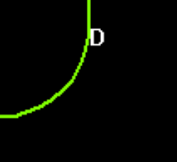

Set Dwell Dialog
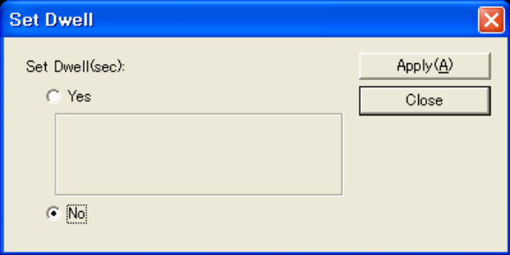
Set Dwell
Specify Dwell option.
Value
- Default
- Enter the default value, 0 second.
- User Defined
- Enter the Dwell value by the second.

11-14. Mesh Line
Use this menu to add a Mesh Line. Select a vector, click on the start point and end point either horizontally or vertically with the data to add with the line as the reference.

Before | After
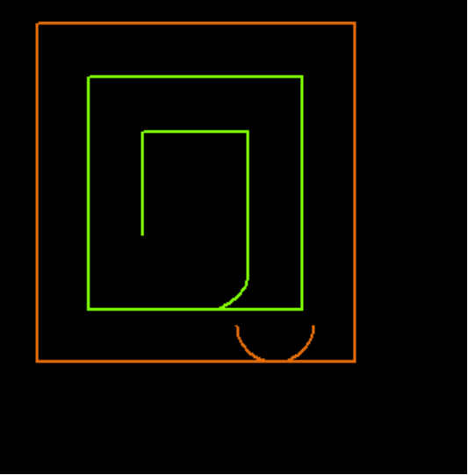 | 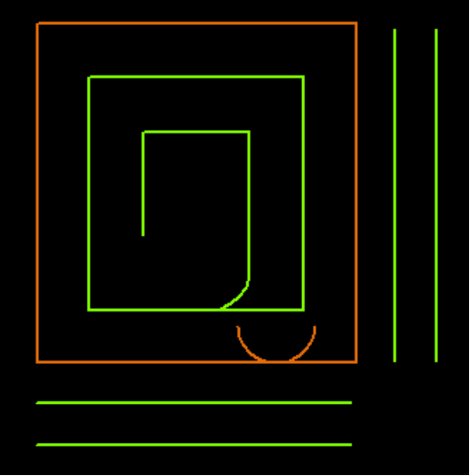

Add Mesh Lines Dialog
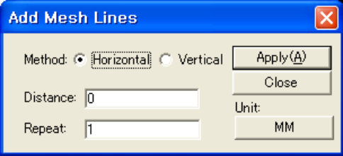
Method
Specify the method to add mesh lines.
- Horizontal
- Add horizontally.
- Vertical
- Add vertically.
Distance
Enter the distance between the Mesh Lines.
Repeat
Enter the number of Mesh Lines.

11-15. Start-End Point
Use this menu to enter the start point or end point for the tool to process the closed curve smoothly.

Add Start-End Point Dialog
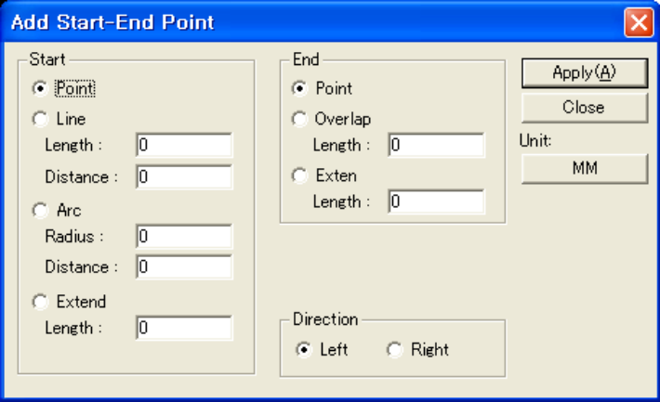
Start – Point
The processing starts from a point.
Start – Line
The processing starts from a line connected by given length and distance.
Start – Arc
The processing starts from an arc connected by given radius and distance.
Start – Extend
The processing starts after moving to the start point of a selected vector by given length.
End – Point
The processing ends at the specified point.
End – Overlap
Already processed section is overlapped by the specified length and the work is finished.
End – Extend
Extend the last processed vector by the specified length.
Direction
Determine the direction where a line or an arc is created when Start-Line or Start-Arc is selected.

11-16. Special Vectors

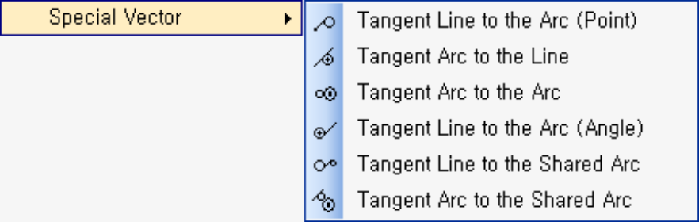

Tangent Line to the Arc (Point)
Add a tangent line to the selected circle by the point.
Tangent Circle to the Line
Add a tangent circle to the selected line.
Tangent Circle to the Arc
Add a tangent circle to the selected arc.
Tangent Line to the Arc (Angle)
Add a tangent line to the selected circle by the angle.
Tangent Line to Two Arcs
Add a tangent line to the selected two circles.
Tangent Circle to Two Arcs
Add a tangent circle to the selected two vectors.

11-16-1. Tangent Line to the Arc (Point)
Use this menu to add a tangent line to the selected circle. Select the circle and click the point on which the tangent line will be drawn.

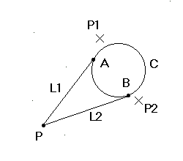
It draws a tangent line to the circle from the point.
Select circle C.
Select point P.
When P1 is selected, tangent line L1 is drawn and when P2 is selected, tangent line L2 is drawn.

11-16-2. Tangent Circle to the Line
Use this menu to add a tangent circle to the selected line. Select the line, and click the center point of the circle.

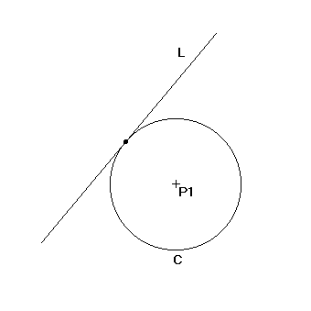
It draws a circle that meets the selected line.
Select line L.
When center point P1 is selected, circle C is drawn.

11-16-3. Tangent Circle to the Arc
Use this menu to add a tangent circle to the selected circle. Select the circle, and click the center point of the circle.

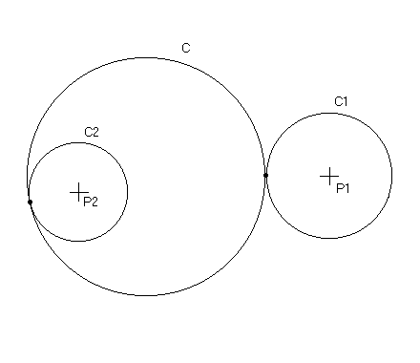
It draws a circle that meets the selected circle.
Select circle C.
When the circle’s center point P1 is selected, circle C1 is drawn and when selecting P2 then circle C2 is drawn.

11-16-4. Tangent Line to the Arc (Angle)
Use this menu to add a tangent line to the selected circle by the angle and length.

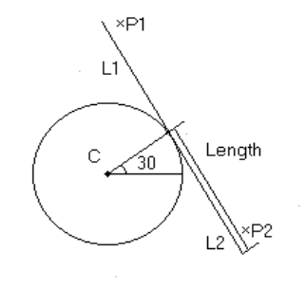 By setting the tangent line’s angle and length, it draws a tangent line to the circle.
Select circle C.
Assign angle and length of the tangent line.
When P1 is selected, draws tangent line L1; and when selecting P2, draws tangent line L2.

Tangent Line to the Arc (Angle) Dialog
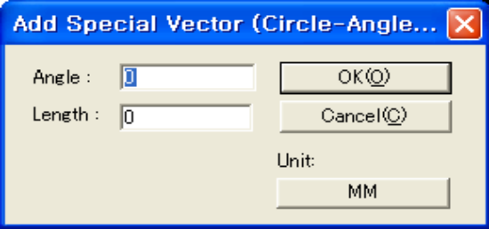
Angle
Enter the rotation angle of the tangent line.
Length
Enter the length of the tangent line.

11-16-5. Tangent Line to Two Arcs
Use this menu to add a tangent line to the two selected circles. Select two circles, and select one from the possible tangent lines presented.

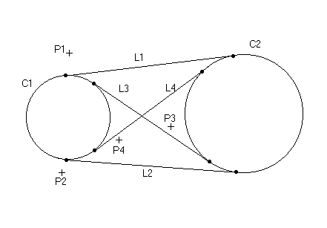
It draws tangent lines that meet two circles.
Select circle C1 and C2.
When P1 is selected, tangent line L1 is drawn; and when selecting P2, P3 and P4 draws tangent lines L2, L3 and L4.

11-16-6. Tangent Circle to Two Arcs
Use this menu to add a tangent circle to the two selected objects.

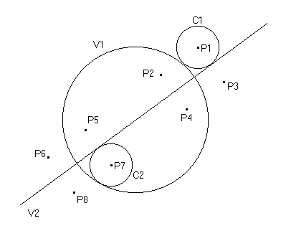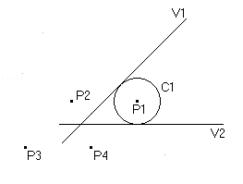

It draws a circle that meets two vectors.
Select two vectors, V1 and V2.
When setting circle’s radius, circle’s center point is shown.
When selecting the circle’s center point P1, C1 is drawn; and when selecting P2, P3 and P4 draws C2, C3 and C4.

Tangent Circle to Two Arcs
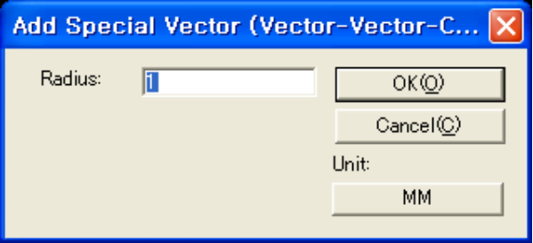
Radius
Enter the radius of the circle to add.

11-17. Break Away Hole
Use this menu to add a Break Away Hole.

Before | After


Add Break Away Hole Dialog
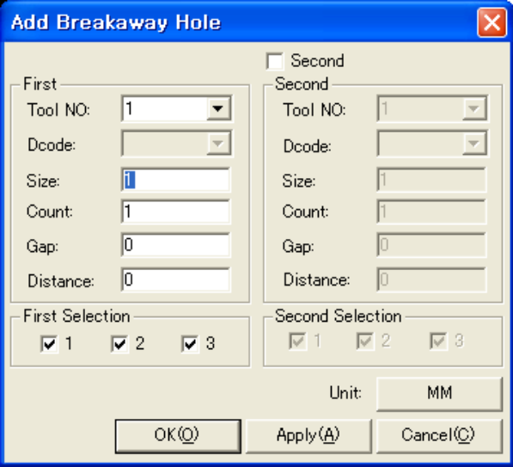
Use Second
Check in addition if the desired number is not satisfied only by First.
First, Second – Tool No
Enter the tool number of the Break Away Hole.
First, Second – DCode
Enter the Dcode of the Break Away Hole.
First, Second – Size
Enter the size of the Break Away Hole.
First, Second – Count
Enter the number of the Break Away Hole.
First, Second – Gap
Enter the gap between the holes in a column.
First, Second – Distance
Enter the distance between the columns formed by the Hole.
First, Second Selection
Check the number of columns.

12. Add(Dimension)

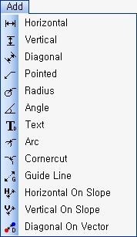 | Horizontal
 | Add a horizontal dimension line.
 | Vertical
 | Add a vertical dimension line.
 | Diagonal
 | Add a diagonal dimension line.
 | Pointed
 | Add a dimension line of a specific point.
 | Radius
 | Add a radius dimension line on the pad.
 | Angle
 | Add an angle dimension line by the angle between lines.
 | Text
 | Add a text dimension line.
 | Arc
 | Add a radius dimension line on the circle.
 | Cornercut
 | Add a cornercut dimension line for an angular edge.
 | Guide Line
 | Arrange the dimension line and add a guide line for drawing.
 | Horizontal On Slope
 | Add a horizontal dimension line on slope.
 | Vertical On Slope
 | Add a vertical dimension line on slope.
 | Diagonal On Vector
 | Add a dimension line representing the distance between vectors.

12-1. Horizontal
This menu adds horizontal dimension line on the specific popcopy.

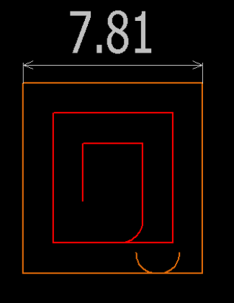

12-2. Vertical
This menu adds vertical dimension line on the specific popcopy.

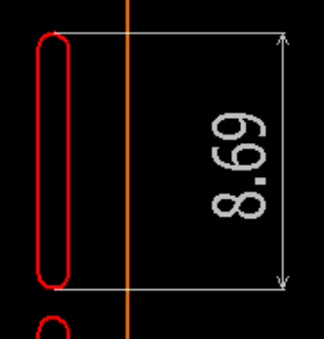

12-3. Diagonal
This menu adds diagonal dimension line on the specific popcopy.

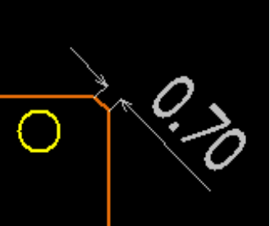

12-4. Pointed
This menu adds a dimension line by marking a specific point with a mouse on the specific popcopy.

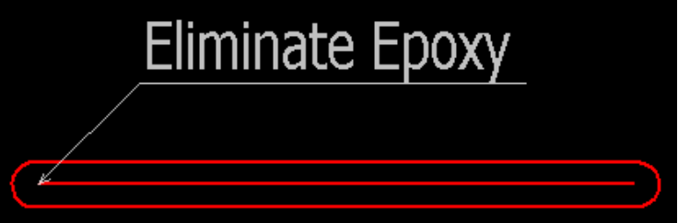

12-5. Radius
This menu adds radius dimension line on the specific popcopy. This radius dimension line works when the pad alone is selected.

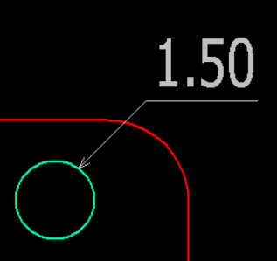

12-6. Angle
This menu adds angle dimension line on the specific popcopy. This dimension line needs selecting lines, and automatically calculates the angle between selected lines.

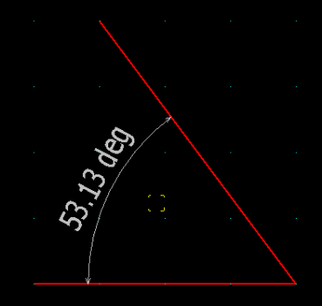

12-7. Text
This menu adds text dimension line on the specific popcopy. The desired text is added to the specifically marked point.

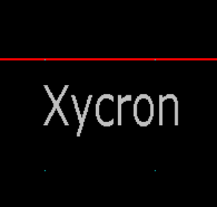

12-8. Arc
This menu adds an arc dimension line on the specific popcopy. This dimension line needs selecting arc vectors, and automatically calculates the radius of the selected arc.

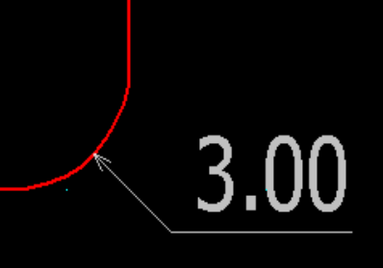

12-9. Cornercut
This menu adds cornercut dimension line on the specific popcopy. This cornercut dimension line needs selecting angular edges, and automatically calculates the distance from the virtual intersection of both lines supporting the edge to the lines respectively.

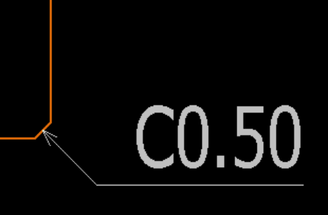

12-10. Guide Line
This menu adds guide line on the specific popcopy. This guideline guides the user to arrange or insert the dimension lines regularly on the desired location.

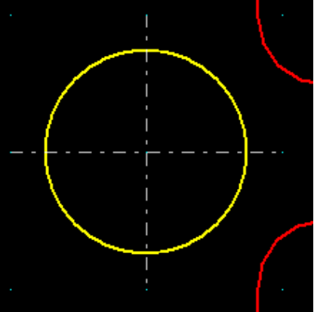

12-11. Horizontal On Slope
This menu adds horizontal on slope dimension line on the specific popcopy. This is applied when the user wants a horizontal dimension line in adding a dimension line on slope.

12-12. Vertical On Slope
This menu adds vertical on slope dimension line on the specific popcopy. This is applied when the user wants a vertical dimension line in adding a dimension line on slope.

12-13. Diagonal On Vector
This menu adds diagonal on vector dimension line on the specific popcopy. This menu adds the distance between a specific vector and another vector diagonally on vector, and automatically calculates the shortest distance between the two vectors.

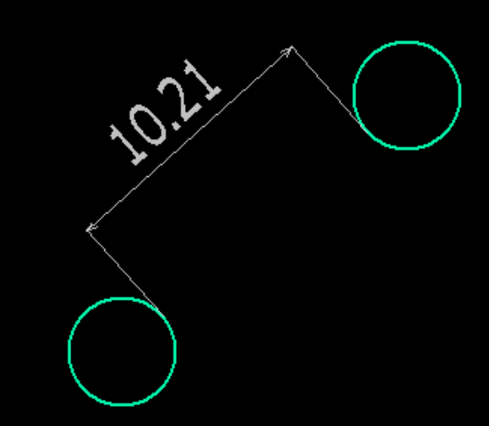

13. Insert(Layout)

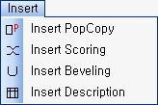 | Insert Popcopy
 | Insert created popcopies.
 | Insert Scoring
 | Insert created scorings.
 | Insert Beveling
 | Insert created bevelings.
 | Insert Description
 | Insert created descriptions.

13-1. Insert popcopy
Use this menu to see the popcopy list created from popcopy mode, and insert it to the active layout.

Popcopy dialog
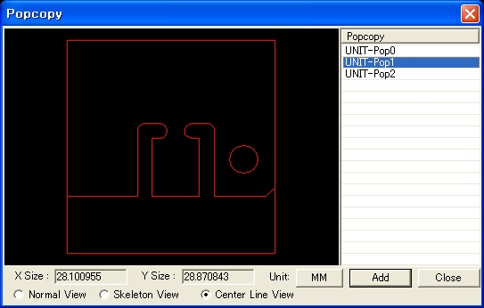
Normal view
The drawing form of the layer of popcopy preview is set to standard.
Skeleton view
The drawing form of the layer of popcopy preview is set to skeleton.
Center line view
The drawing form of the layer of popcopy preview is set to center line.

13-2. Insert Scoring
Use this menu to see the created scoring list, and insert it to the active layout.

Scoring dialog
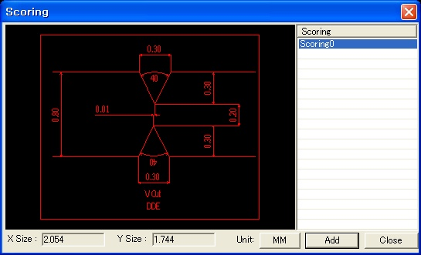
Scoring List
Show the scoring list and preview.

13-3. Insert Beveling
Use this menu to see the created beveling list, and insert it to the active layout.

Beveling dialog
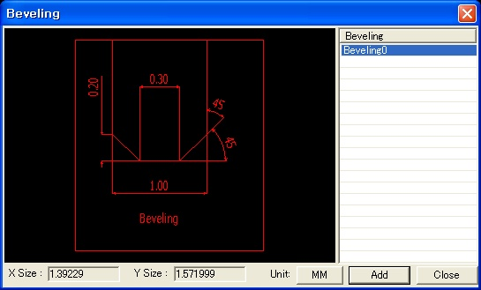
Beveling List
Show the beveling list and preview.

13-4. Insert Description
Use this menu to see the created description list, and insert it to the active layout.

Description dialog
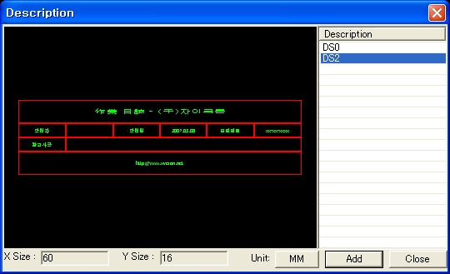
Description List
Show the description list and preview.

14. View

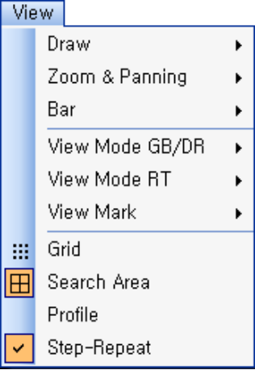 | View ▶
 | Specify home and redraw.
 | Zoom & Panning ▶
 | Zoom or Pan
 | Bar ▶
 | Show or hide the bar.
 | View Mode GB/DR ▶
 | Specify the form of Gerber vector view
 | View Mode RT ▶
 | Specify the form of Router Bit Simulation view.
 | View Mark ▶
 | Specify the Mark view.
 | Grid
 | Specify the Grid view.
 | Search Area
 | Specify the form of search area.
 | Profile
 | Show or hide the profile.
 | Step-Repeat
 | Show or hide the step-repeated work.

14-1. Draw ▶

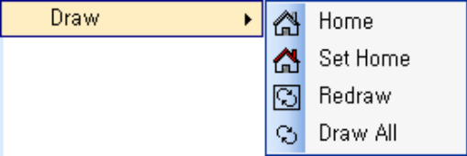 | Home
 | Fill the screen by the specified size of home area.
 | Set Home
 | Set the current screen as home.
 | Redraw
 | Redraw the screen.
 | Draw All
 | Fill the screen by the size of data area.

14-1-1. Home
This menu displays the current window area as the home screen ratio already specified, and the location of view area. It does not need mouse use.

14-1-2. Set Home
This menu sets the screen ratio of the current work window area and the location of view area as home. If you set the area ratio and location of view area you usually use, restoring to home can be very fast even though you are editing the other area. It does not need mouse use.

14-1-3. Redraw
This menu redraws all data clearly when the display is not clear because of broken data or afterimages in the current work window area. It does not need mouse use.

14-1-4. Draw All
This menu displays all data existing in the current work window area integrated into the work window area. Therefore, if data have very big size, they will be displayed in the work window area. It does not need mouse use.

14-2. Zoom & Panning ▶

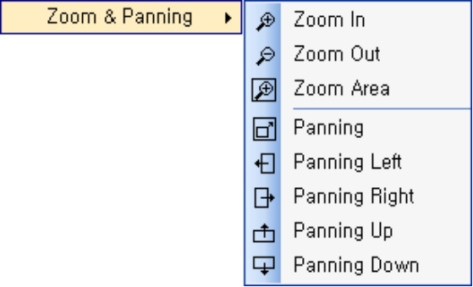 | Zoom In
 | Enlarge by the specified ratio.
 | Zoom Out
 | Shrink by the specified ratio.
 | Zoom Area
 | Fill the screen with the specified area.
 | Panning
 | Move the screen to the specified direction.
 | Panning Left
 | Move the screen to the left.
 | Panning Right
 | Move the screen to the right.
 | Panning Up
 | Move the screen up.

Panning Down
Move the screen down.

14-2-1. Zoom In
Use this menu to enlarge the area of interest with a point clicked by the mouse as the center in the current work window area. Select the command (Cursor mode turns to Zoom in mode.) and click the area to enlarge in the work window. Move the cursor to the desired location and click to enlarge the current work window area. Another click will enlarge the data more.

14-2-2. Zoom Out
Use this menu to shrink the area of interest with a point clicked by the mouse as the center in the current work window area. Select the command (Cursor mode turns to Zoom out mode.) and click the area to shrink in the work window. Move the cursor to the desired location and click to shrink the current work window area. Another click will shrink the data more.

14-2-3. Zoom Area
Use this menu to enlarge the area of interest using a rectangular area in the current work window area. Select the command (Cursor mode turns to Zoom in mode.), move the cursor to the desired location, click on the left mouse button, and after moving the cursor to the desired location, click on the left mouse button again, to enlarge the selected area.

14-2-4. Panning
Use this menu to move to the area of interest from the current work window. Select the command (Cursor mode turns to Pannig mode.), move the cursor to the desired location, click on the left mouse button, and after moving the cursor to the desired location, click on the left mouse button again, to pan by the distance between the clicked two points.

14-2-5. Panning Left
Use this menu to move the current work window area to the left. It does not need mouse use.

14-2-6. Panning Right
Use this menu to move the current work window area to the right. It does not need mouse use.

14-2-7. Panning Up
Use this menu to move the current work window area up. It does not need mouse use.

14-2-8. Panning Down
Use this menu to move the current work window area down. It does not need mouse use.
This menu is used to show or hide the specified bar.

14-3. View Mode GB/DR ▶
Fill
Draw the vector as filled.
Skeleton
Draw the outline of a vector.
Center
Draw the center line of a vector.

There are 3 modes such as Fill, Skeleton, and Center in the Gerber Vector view menu. It works only on Gerber data. Click on the “V” key changes the mode.

Draw | Description
 | <Fill>  This displays each vector of which the 2 dimensional space is filled with the specified color.
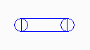 | <Skeleton>  This displays the outline of each vector of which the 2 dimensional space is not filled with the specified color.
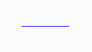 | <Center>  This displays the center line of each vector in a specified color. However, a pad or a drill is displayed in the skeleton method.

14-4. View Mode RT ▶
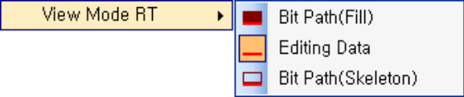 | Bit Path(Fill)
 | Draw the editing data with Bit Path as filled
 | Editing Data
 | Draw the editing data only
 | Bit Path(Skeleton)
 | Draw the editing data with Bit Path as outlines.

There are 3 modes such as Bit Path(Fill), Editing Data, and Bit Path(Skeleton) in the View Mode RT menu. Click on the B key changes the mode.

Draw | Description
 | <Bit Path(Fill)>
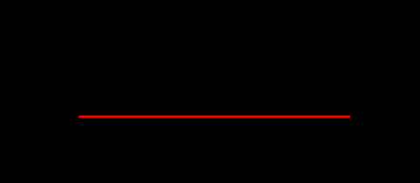 | <Editing Data>
 | <Bit Path(Skeleton)>

14-5. View Mark ▶
Start Point
Specify the Start Point Mark view.
Middle Point
Specify the Middle Point Mark view.
Direction
Specify the Vector Direction Mark view.

14-5-1. Start Point | 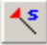
Use this menu to display the start point mark of each vector group.

Router |  | Gerber
Start Point(Point) | Start Point(Arc) | Gerber
 | 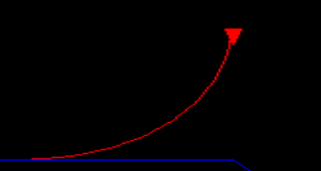 | 

14-5-2. Middle Point | 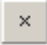
Use this menu to display “X” mark at the middle point of each vector group.

ON | OFF
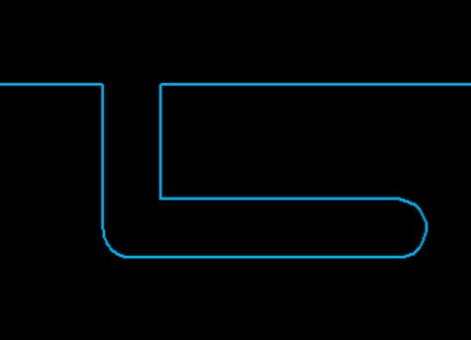 | 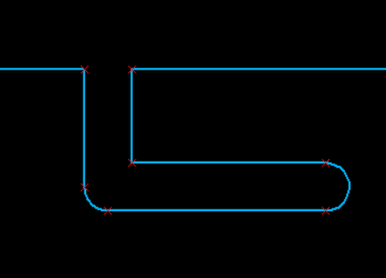

14-5-3. Direction
Use this menu to display the direction mark of each vector.

Before | After
 | 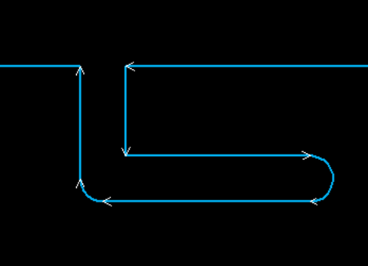

14-6. Grid
Use this menu to display grid in the work window area. When the grid is displayed in the work window area, select <View::Grid> menu to remove grid, and when the grid is not displayed in the work window area, select <View::Grid> menu to display the grid.

14-7. Search Area
Use this menu to select objects by search area. When the search area button before the menu name is pushed, you can see the area as follows.

ON | OFF
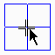 | 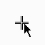

Select <View::Search area> menu for the search area button not to be pushed, to select objects by search area deactivated.

14-8. Profile
Use this menu to display profile in the work window area. When the profile is displayed in the work window area, select <View::Profile> menu to remove profile, and when the profile is not displayed in the work window area, select <View::Profile> menu to display the profile.

ON | OFF
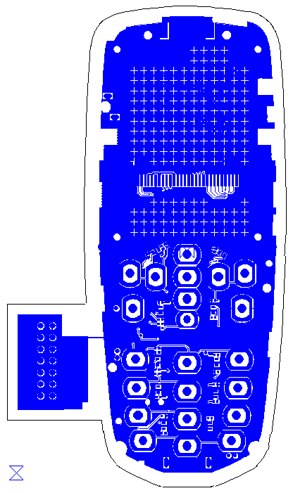 | 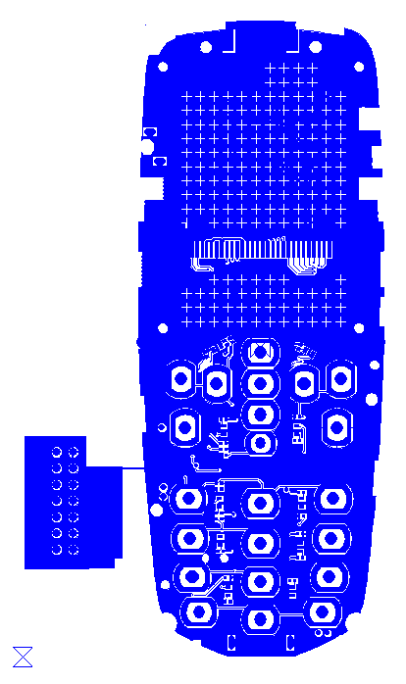

14-9. Step-Repeat
This menu applies to the work with step-repeat information, not performing any action to the work without step-repeat information. Select <View::Step-Repeat> menu to see the PCB data in the sub panel of the work with step-repeat information when it is activated. Then a pushed button appear before the menu name, and you can see the PCB data in the sub panel of the work in activation. Select <View::Step-Repeat> menu to hide the PCB data in the sub panel. Pushed button exists before the menu name when step-repeat is activated, but the button does not exist when step-repeat is deactivated.

ON | OFF
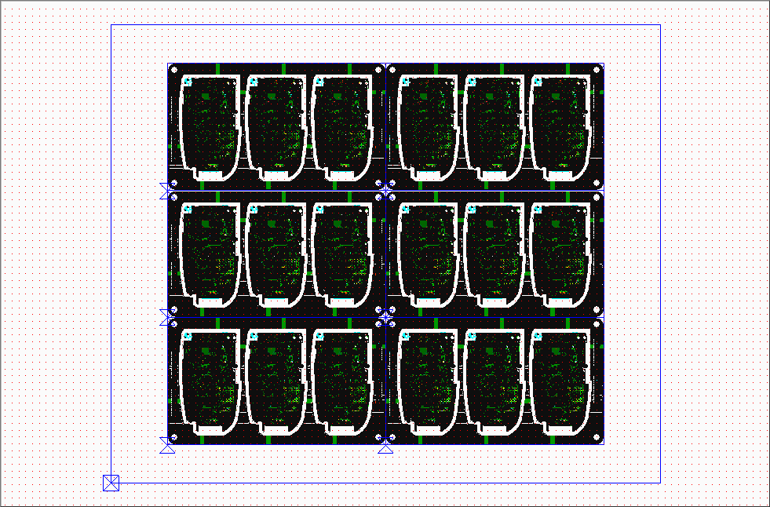 | 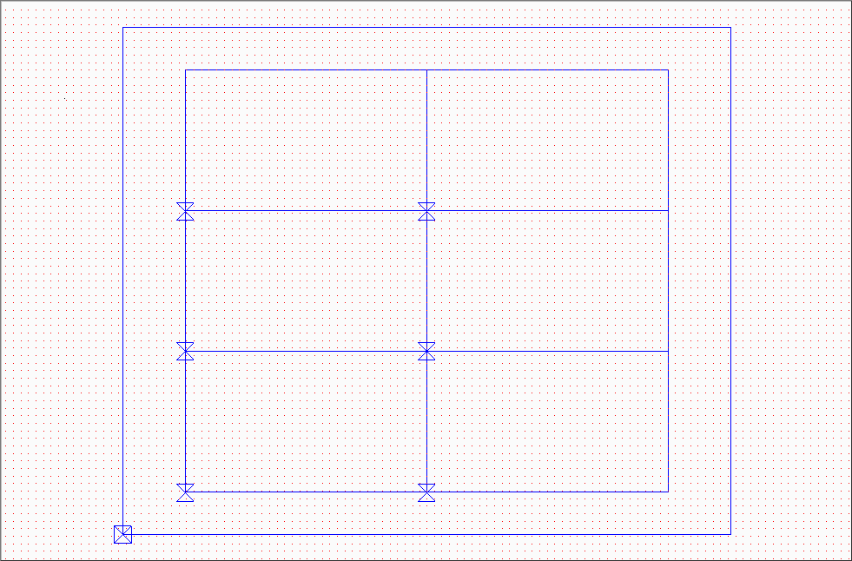

15. Job

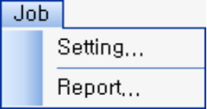 | Setting...
 | Set attributes of current job.
 | Report...
 | Display the details of the current job in a report.

15-1. Setting...
Use this menu to set attributes on the task. Select <Job::Setting…> menu to see <Set Job Attributes> Dialog Box. Select attributes to change, specify the attributes on the right by clicking the items to change, and click the OK button.

Set Job Attributes
Job Attributes Page
Change the attributes of the selected jobs.

15-2. Report...
Use this menu to print the attributes and values on the job. Select <Job::Report…> and print a report. Not working now.

16. Layout

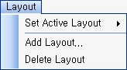 | Set Active Layout ▶
 | Select a layout to work on among the plural layouts.
 | Add Layout..
 | Add a layout.
 | Delete Layout
 | Delete the current active layout.

16-1. Set Active Layout ▶
Use this menu to select a layout to work on among the created layout lists.

Layout list
Display the created layout lists.

16-2. Add layout..
Use this menu to create a new layout.

Add Layout
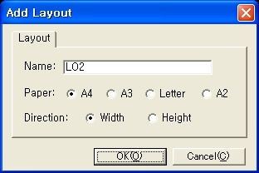
Name
Enter the name of a new layout.
Paper
One of the 4 papers(A4, A3, A2, postcard) can be selected for paper.
Direction
Horizontal or vertical direction can be selected for the paper with the selected layout.

16-3. Delete layout
Use this menu to delete the active layout. The dialog box below pops up to confirm the user’s intention to delete, and it is deleted finally.
Notify
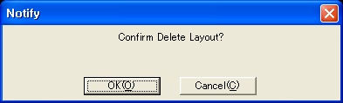

17. Work

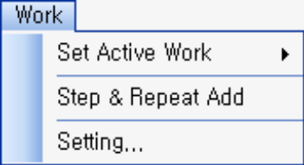 | Set Active Work ▶
 | Select the work to edit.
 | Add Step & Repeat
 | Add a new work.
 | Setting...
 | Set attributes of current work.

17-1. Set Active Work ▶
Use the menu to select a work to activate when plural works are loaded because one project or job can have plural works. Select <Work::Set Active Work> menu and the work to activate.

Set Active Work
2 works exist now.
Select a work to edit among the 2 works.

17-2. Add Step & Repeat
Use this menu to enter step-repeat information to add a panel.

Step-Repeat Setting Dialog
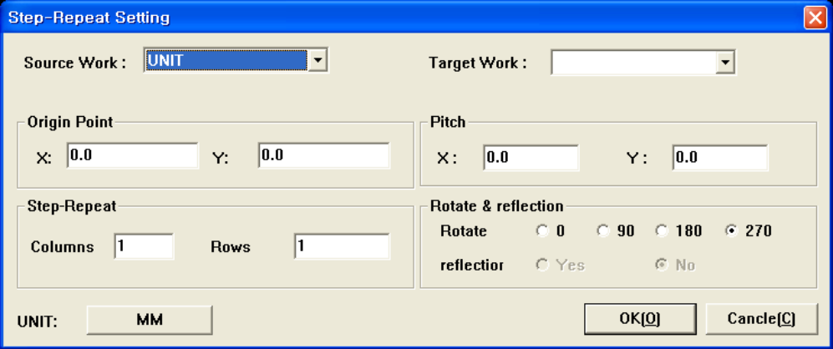
Source Work
Select the work to step-repeat.
Target Work
Select the work to step-repeat. Enter a new work name to step-repeat by adding a new work.

Origin Point
Specify the origin of the work to step-repeat.
Repeat
Enter the step-repeat value.
Pitch
Enter the pitch between the works to step-repeat.
Rotate & Mirror
Rotate or reflect the work to step-repeat.

17-3. Setting...
Use this menu to set attributes on the work. Select <Work::Setting…> menu to see <Set Work> Dialog Box. Select works to change, specify the attributes on the right by clicking the items to change, and click the OK button.

Set Work
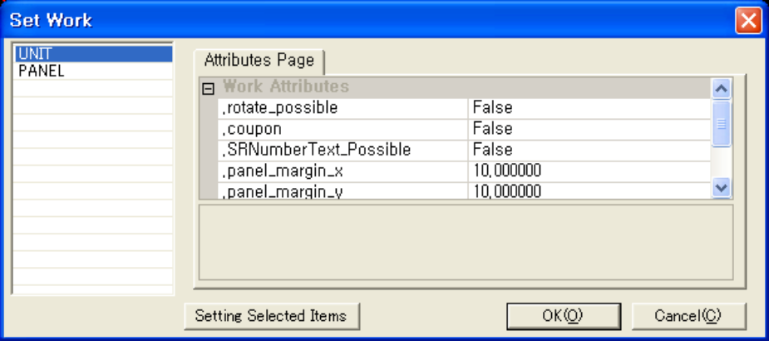
Work List
Select the work of which the attributes needs to be changed.
Attribute Page
Change the attributes of the selected work.

18. Layer

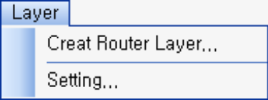 | Create Router Layer...
 | Create a Router layer.
 | Setting
 | Set the attributes of current layer.

18-1. Create Router Layer...
Use this menu to create a Router layer.

Add Router Layer Dialog
Name
Enter the name of the layer to add.

18-2. Setting..
Use this menu to set the attributes on the layer. Select <Layer::Setting…> menu to see <Layer Setting> Dialog Box. Select items to change, specify the attributes on the right, and click the OK button.

Layer Setting Dialog

Layer List
Select the layer of which the attributes needs to be changed.
Attribute Page
Change the attributes of the selected layers.

19. Utility

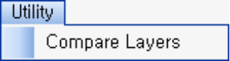 | Compare Layers
 | Compare Router layers.

19-.1 Compare Layers
Use this menu to compare two Router layers.

Router Layer Compare
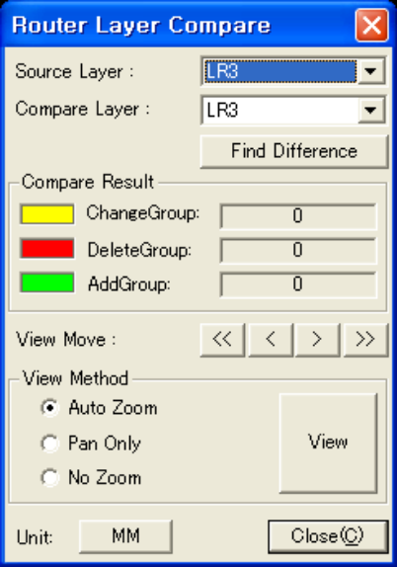
Source Layer
Specify the source layer to compare.
Compare Layer
Specify the target layer to compare.
Find Difference
Display the differences searched by the click as indicated in view method.
Compare Result
Compare two Router layers and show the number of changed, deleted, and added groups.
View Move
Move from the current vector group to another vector group.

View Method
A method to view differences.
- Auto Zoom
- Display the vector group with difference fitted to the screen.
- Pan only
- Move the vector group with difference from the current location to the center.
- No Zoom
- Maintain the current state.

20. Tool

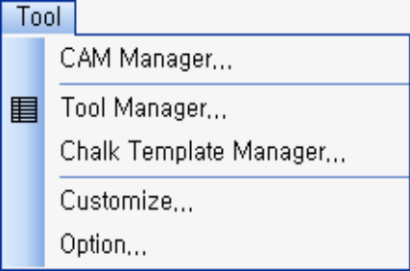 | CAM Manager…
 | Specify the work and layer information.
 | Tool Manager…
 | Specify aperture(Gerber), drill tool(drill), Router tool(Router).
 | Chalk Template Manager…
 | Add, change, or delete the chalk template.
 | Customize…
 | Not working now.
 | Option…
 | Set various options.

20-1. CAM Manager…
CAM Manager menu consists of work manager and symbol manager. Select <Tool::CAM Manager…> menu.

20-1-1. Work Manager
Use this menu to add, delete, and change works, or add, delete, and change layers and the order of layer using Work Manager tab. Physical attributes of each layer can also be changed.

CAM Manager Dialog
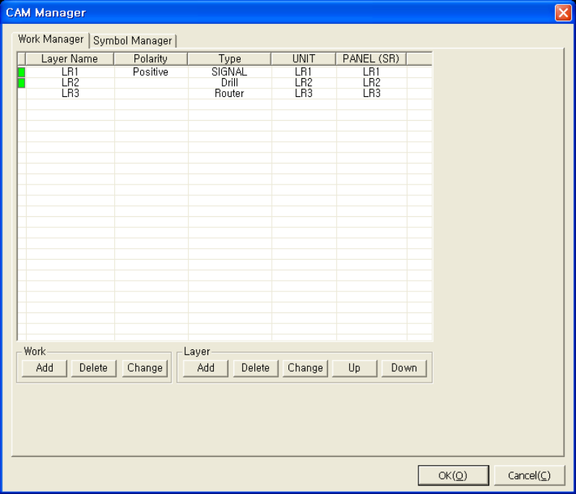
Work List
Display the structure of current specified work.
Work – Add
Add a new work.
Work – Delete
Delete the selected work. Click the specified work name in the list header to select a work.
Work – Change
Change the contents of the selected work. Use <Parameter Page> Dialog Box.
Layer – Add
Add a new layer. Use <Change Layer Attributes> Dialog Box.
Layer - Delete
Delete the selected layer. Click the layer name on the list to select a layer.
Layer – Change
Change the contents of the selected layer. Use <Change Layer Attributes> Dialog Box.
Layer – Up
Raise the selected layer up by one order.
Layer – Down
Lower the selected layer down by one order.

Parameter Page Dialog Box
S&R List
Show the step-repeat information of the selected work. The attributes can be selected and changed.
Work – Name
Change the name of the selected work.
Work – Add
Enter a new step-repeat information.
Work – Modify
Modify the step-repeat information selected on the step-repeat list.
Work – Delete
Delete the step-repeat information selected on the step-repeat list.
Panel Size
Specify the size of the selected work(panel).
- Registered Size
Select from the registered size in the option dialog box.
- Used Size
The user can specify arbitrary size.

Change Layer Attributes
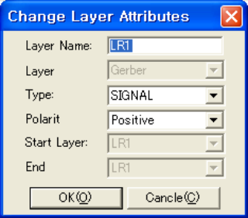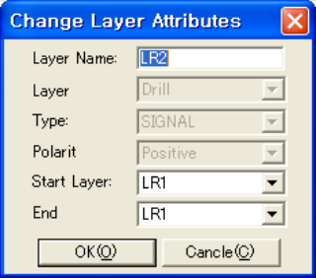
Layer Name
Change the name of a layer.
Layer Type
Change the type of a layer. (Gerber, drill, router)
Type
Valid only if the layer type is Gerber. Specify the type of Gerber layer.
Polarity
Valid only if the layer type is Gerber. Specify the polarity of Gerber layer.
Start Layer
Valid only if the layer type is the drill. Specify the start layer from which the drilling starts.
End Layer
Valid only if the layer type is drill. Specify the end layer at which the drilling ends.

20-2. Tool Manager..
Among the existing data in the layer, aperture, drill tool, and router tool are called chalks. Use <Tool::Tool Manager> menu to add, delete, and change the chalk. Select <Tool::Tool Manager…> menu. <Tool Manager> Dialog Box pops up.

Tool Manager Dialog Box (Gerber Layer)
Layer List
Select the layer to change.
Aperture List
Display the list of apertures used in the selected layer. Select an aperture to see the attributes on the attribute list.
Aperture View
Display the shape of the selected aperture.
Attribute List
Display the attributes of the selected aperture. The contents change according to each aperture type. The attributes can be selected and changed. Click on the update button after modification for it to have an effect.
Add
Add an aperture. A new aperture is added to an empty Dcode on the list.
Delete
Delete an aperture selected on the aperture list. An aperture in use cannot be deleted.

Report…
The aperture list used in the layer can be printed as a report.
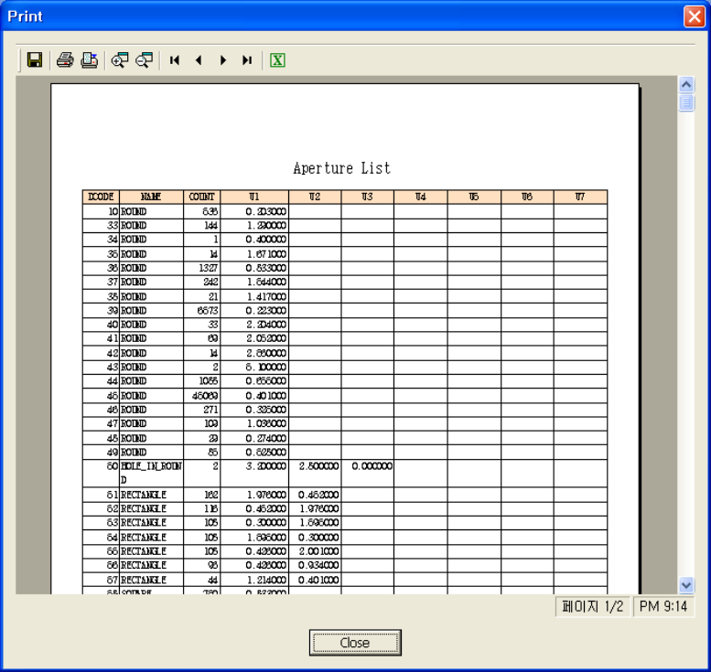
Update
Apply the changed values on the list to the selected aperture.
Reset
Initialize the attributes of the attribute list.
Preview
Preview the aperture consisting of the attributes specified on the attribute list.

Layers are shown on the left layer. Click a layer to see the list of chalks existing on the selected layer in the aperture tab(the table in the middle). Dcode, name, count, and values are displayed on the chalk list. Click the Dcode, name, count, or value for ascending and descending sort.

Click the chalk to see the shapes and attributes of the chalk in the right area. The shape of the chalk is displayed in the upper area, and the attributes and the values are displayed below.

Tool Manager Dialog Box (Drill Layer)
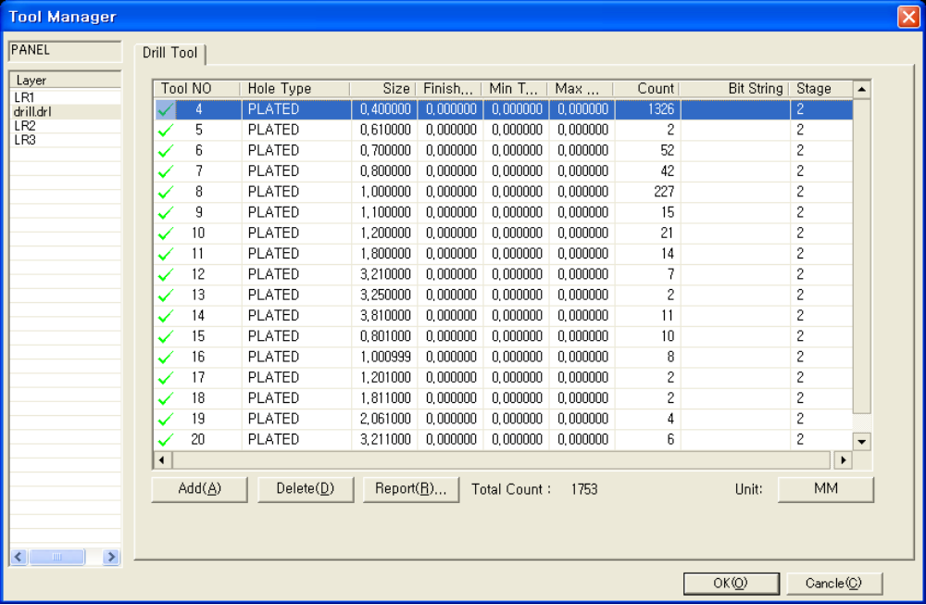
Layer List
Select the layer to change.
Drill Tool List
Display the list of the drill tools in the form of attribute table. Information of hole type, size, etc. can be changed.
Add
Add a drill tool. The new drill tool is added to the empty tool number on the list.
Delete
Delete the selected drill tool on the drill tool list. A drill tool in use cannot be deleted.

Report…
The list of drill tools used in the layer can be printed as a report.
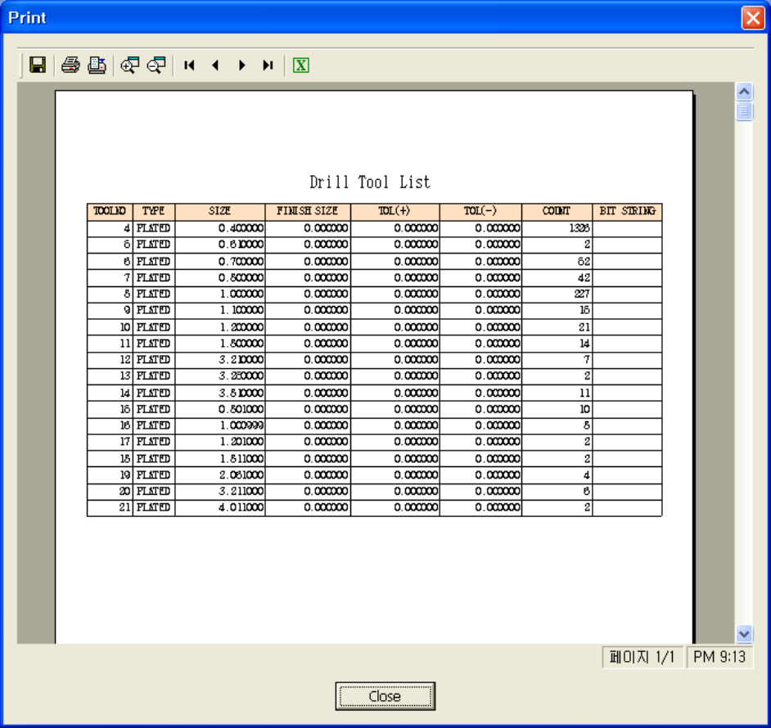
Total Count
Display the number of all vectors existing on the selected layer.

Tool Manager Dialog Box (Router Layer)
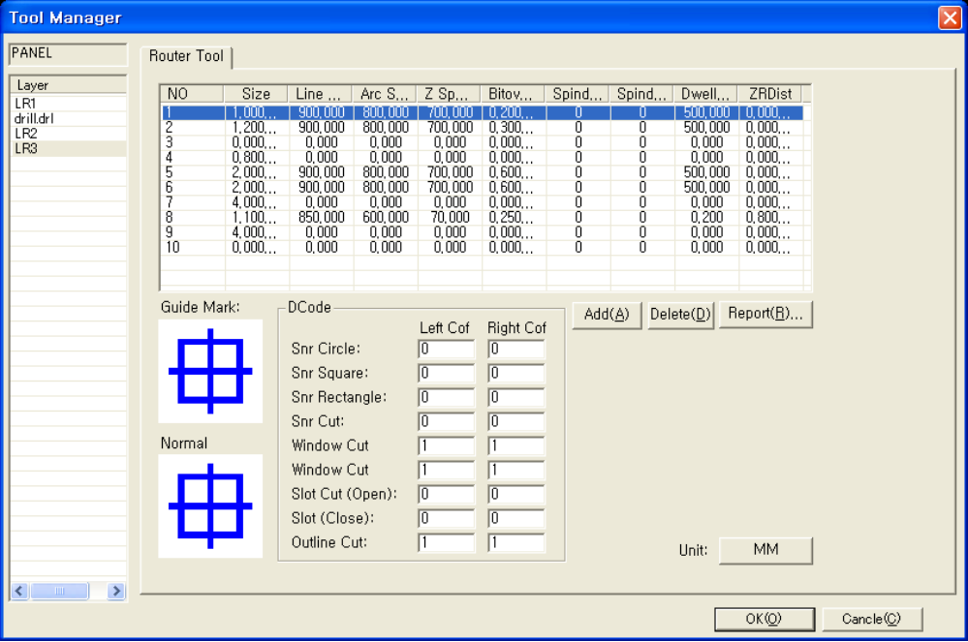
Layer List
Select the layer to change.
Router Tool List
Display the list of the router tools in the form of an attribute table. Information of size, line velocity, arc velocity, Z velocity, etc. can be changed.
Add
Add a router tool. The new router tool is added to the empty tool number on the list.
Delete
Delete the selected router tool on the router tool list. A router tool in use cannot be deleted.
Report...
The router tool list used in the layer can be printed as a report. Not working now.
DCode
Enter the compensation Dcode according to the cutting type.

20-3. Chalk Template Manager
Chalk template refers to a definition of the rule to translate an arbitrary chalk file. The user can open a chalk file using the chalk template manager menu, specify a chalk shape of each datum to create a chalk template, or open an existing chalk template (nct file) to modify.
In order to translate a new chalk file, the user can create a chalk template conforming to the new chalk file.
Select <Tool::Chalk Template Manager…> menu. <Chalk Template Manager> Dialog Box pops up.

Chalk Template Manager Dialog
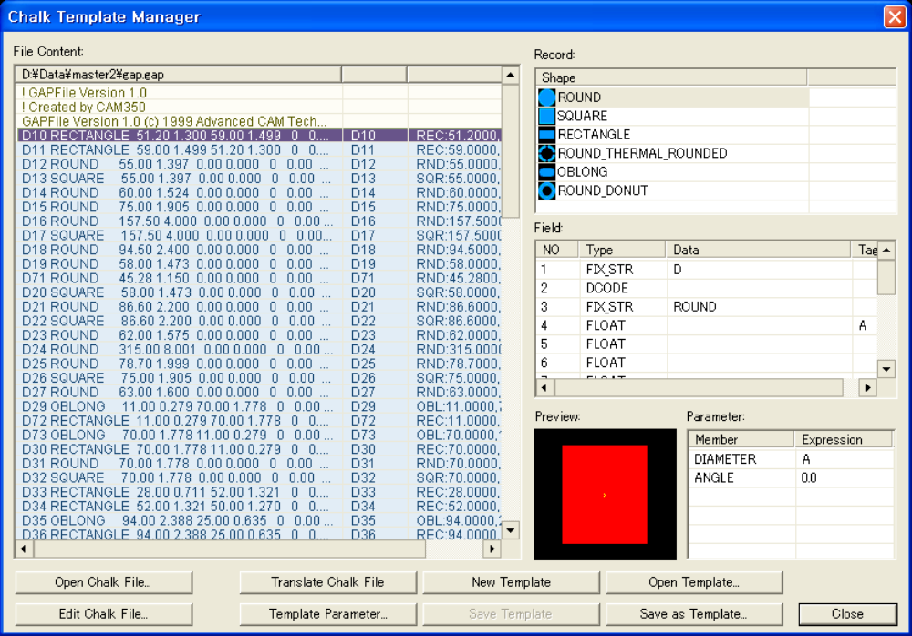
File Content
Display the contents of an open chalk file, with translatable lines in another color.
D# and contents of the translated chalk files are displayed in the symbol column.
Select the translatable lines to see the shape in the preview pane.

Record List
The list of records used in translation.
Select the line to translate in the file to add a new record.
Then, <Chalk Shape Select> Dialog Box will pop up.
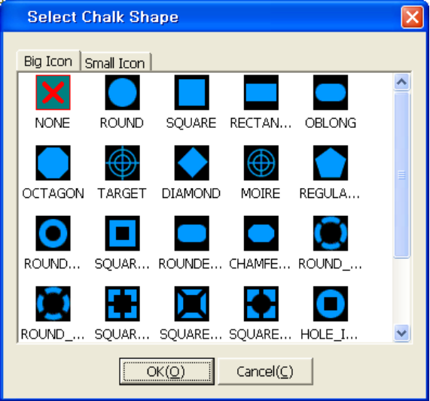
Select the chalk shape. Arrange the details on the field list.
Field List
Display the details of the line to translate in the split form.
The types below can be specified for each field.
- DCODE : Dcode (Tool number) field
- FIX_STR : Fixed string field
- FIX_INT : Fixed integer field
- INT : Integer field
- FLOAT : Real number field
- STR : String field
- ALPHA : Alphabet field
- ANY : Anything
- END : The last field
Click the tag column to specify each tag in the field displaying details for the parameter.
(e.g.) Find fields for width and height for a rectangular type, and attach the tag A and B.
Preview
Preview the translated shape of the chalk when the translated line is selected.

Parameter List
Determine each parameter using the tag information specified on the field list.
Simple four fundamental calculations are possible on the field list.
(e.g.1) Specify tag_A as the width, and tag_B as the height for the rectangular type.
(e.g.2) Specify tag_A as the width, and tag_A x 2 as the height for the rectangular type.
Open Chalk File...
Open a chalk file to translate.
Edit Chalk File..
Edit a chalk file by opening a memo window.
Translate Chalk File
Translate a file by records specified until now and display the translated lines.
New Template
Create a new template.
Open Template
Open the existing template and edit.
Template Parameter...
Then, <Chalk Template Parameter> Dialog Box pops up.
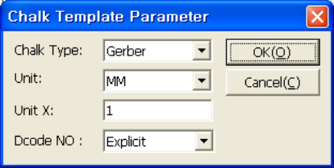
- Chalk type: Specify the layer on which the template is used. (Gerber, drill)
- Unit: Specify the unit to be used in the template.
- Unit X: Specify the multiple of the unit.
(e.g.) cm unit: Specify the unit as mm, and Unit X as 10.
- Numbering Dcode: Specify the algorithm to determine the Dcode number.
Save Template
Save the current template.
Save As Template..
Save the current template as a new file.

20-4. Customize...
Change the tool bar, menu, shortcut key options, etc. at your disposal.

20-5. Option
Specify options for the program. There are grid/select area, color, note, work, name, data snap, display, miscellaneous, etc. which can be specified in details. Select <Tool::Option> menu. <Option> Dialog Box pops up.

Option Dialog – Grid / Select Area Page
Mode
Specify grid/select area according to each mode. (work, symbol, layout mode)
Grid Size
Specify the size of grid displayed in the selected mode. The specified grid is displayed on the main screen.
Grid OX, OY
Specify the origin of the grid for the selected mode. When you start the grid from a specified point, enter the value other than the origin.
Select X, Select Y
Specify the size of the selected area(a rectangular area for selecting data) by pixel.

Option Dialog – Color Page
Gerber Layer
Specify the color information used for the initial value in creating the Gerber layer.
Drill Layer
Specify the color information used for the initial value in creating the drill layer.
Etc
- Origin: Color of the origin
- Datum: Color of the datum specified at work or symbol
- Profile: Profile color of the work
- Grid: Color of grid points
- Edit: Color of the selected data
- Active: Color indicating the active layer in the layer bar
- Affective: Color indicating the affective layer in the layer bar
- Area: Color of the selected area(the rectangular area for selecting data)
- Note: Color of the note

Option Dialog – Router Color Page
Tool
Specify the color for each tool.
Type
Specify the color for each type.
DCode
Specify the color for each Dcode.
Compensation
Specify the color for the compensation direction.

Option Dialog – Work Page
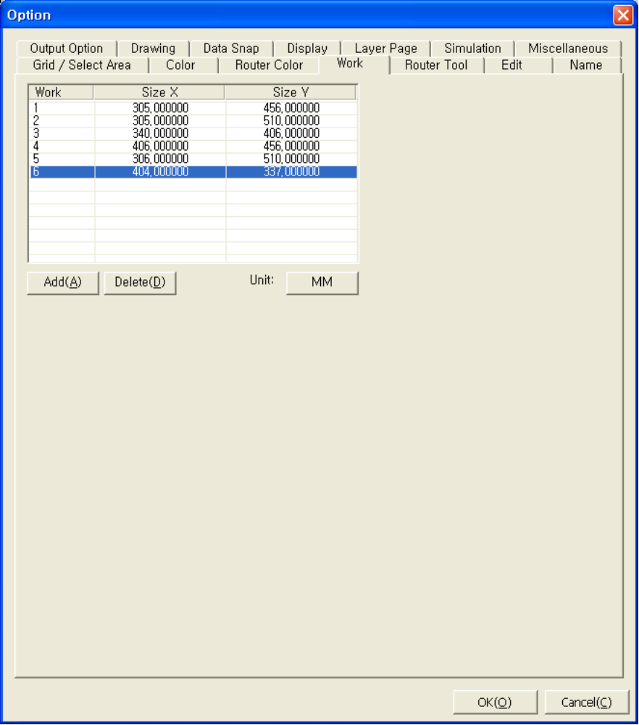
Work Size List
Display the sizes of the specified work(panel).
Add
Add a new work (panel) size.
Delete
Delete the selected work (panel) size.

Option Dialog – Router Tool
Router Tool List
Display the list of the router tools in the form of attribute table. Information of size, line velocity, arc velocity, Z velocity, etc. can be changed.
Add
Add a router tool. The new router tool is added to the empty tool number on the list.
Delete
Delete the selected router tool on the router tool list.
A router tool in use cannot be deleted.
Report...
The router tool list used in the layer can be printed as a report. Not working now.
DCode
Enter the compensation Dcode according to the cutting type.

Option Dialog – Edit Page
Spiral Direction
Specify the default processing direction in adding spiral processing data.

Option Dialog – Name Page
Name
Specify the initial name for creating each datum.
(e.g.) When Work is specified as WK, the work names are set as WK1, WK2, …

Option Dialog : Output Option (Excellon)
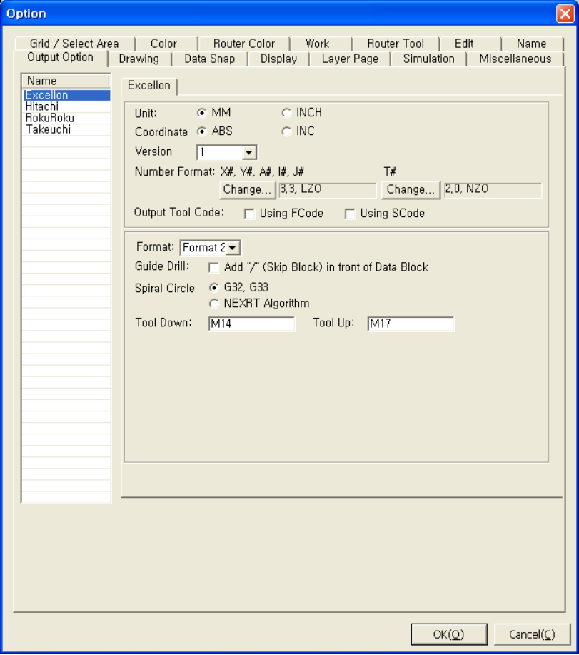
Unit
Specify the unit.
- Metric system - mm
- Inch system - inch
Coordinate
Specify the coordinate.
- Absolute system – Absolute coordinate
- Relative system – Relative coordinate

Version
Select one among 1~8. Version consists of 8 combinations of X axis and Y axis.
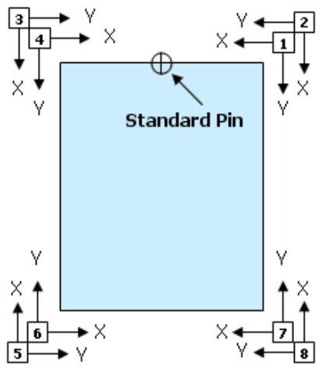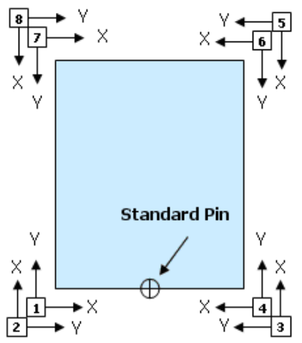

Number Format
- Determine the type of number output with X# Y# A# I# J# - X, Y, A, I, J code.
- Determine the type of number output with T# - T code.
Tool Code Option
- F code – Tool code is outputted along with F code.
- S code – Tool code is outputted along with S code.
Format
Select the excellon output format. There are format1 and format2.
Guide Drill
Determine the output of ‘/(Block Delete)’ before data block.
Spirally processed circle
Select the method to output spirally processed circle data.
- Process by G32, G33 – Output spirally processed circle data by G32, G33
- Process by NEXRT’s own algorithm – Output the processing path by NEXRT’s own algorithm.
Tool Down
Specify the tool down code.
Tool Up
Specify the tool up code.

Option Dialog - Output Option (Hitachi)
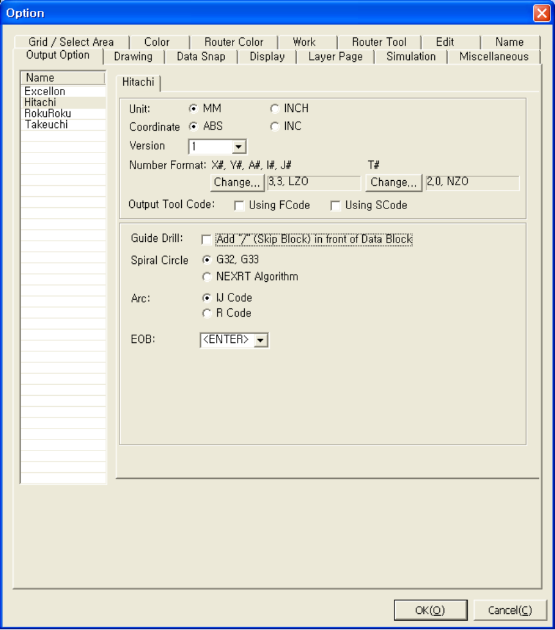
Unit
Specify the unit.
- Metric system - mm
- Inch system - inch
Coordinate
Specify the coordinate.
- Absolute system – Absolute coordinate
- Relative system – Relative coordinate

Version (Coordinate)
Select one among 1~8. Version consists of 8 combinations of X axis and Y axis.
Number Format
- Determine the type of number output with X# Y# A# I# J# - X, Y, A, I, J code.
- Determine the type of number output with T# - T code.
Tool Code Option
- F code – Tool code is outputted along with F code.
- S code – Tool code is outputted along with S code.
Guide Drill
Determine the output of ‘/(Block Delete)’ before data block.
Spiral Drill
Select the method to output spirally processed circle data.
- Process by G32, G33 – Output spirally processed circle data by G32, G33
- Process by NEXRT’s own algorithm – Output the processing path by NEXRT’s own algorithm.
Arc
- IJ code – Output an arc by IJ code.
- R code – Output an arc by R code.
EOB
Select the character for the end of the block.

Option Dialog - Output Option (Roku Roku)
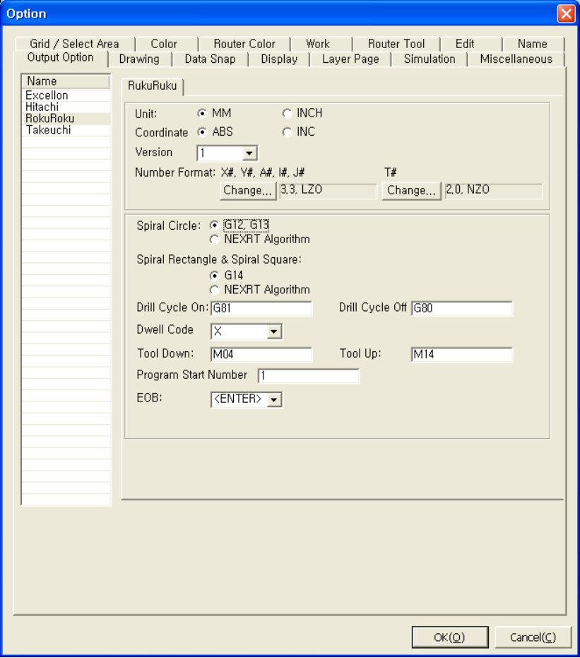
Unit
Specify the unit.
- Metric system - mm
- Inch system - inch
Coordinate
Specify the coordinate.
- Absolute system – Absolute coordinate
- Relative system – Relative coordinate

Version (Coordinate)
Select one among 1~8. Version consists of 8 combinations of X axis and Y axis.
Number Format
- Determine the type of number output with X# Y# A# I# J# - X, Y, A, I, J code.
- Determine the type of number output with T# - T code.
Spiral Drill
Select the method to output spirally processed circle data.
- Process by G12, G13 – Output spirally processed circle data by G12, G13
- Process by NEXRT’s own algorithm – Output the processing path by NEXRT’s own algorithm.
Spiral Rectangle & Spiral Square
- Process by G14 – Output spirally processed rectangular data by G14.
- Process by NEXRT’s own algorithm – Output the processing path by NEXRT’s own algorithm.
Drill Cycle On
Enter the code starting a drill cycle.
Drill Cycle Off
Enter the code ending a drill cycle.
Dwell Code Option
- X – Use X code to specify dwell time in outputting dwell code(G04).
- P – Use P code to specify dwell time in outputting dwell code(G04).
Tool Down
Enter the tool down code.
Tool Up
Enter the tool up code.
Start No of Sub Program
Enter the starting number for the sub program name in creating a sub program.
EOB
Select the character for the end of the block.

Option Dialog - Output Option (Takeuchi)
Unit
Specify the unit.
- Metric system - mm
- Inch system - inch
Coordinate
Specify the coordinate.
- Absolute system – Absolute coordinate
- Relative system – Relative coordinate

Version (Coordinate)
Select one among 1~8. Version consists of 8 combinations of X axis and Y axis.
Number Format
- Determine the type of number output with X# Y# A# I# J# - X, Y, A, I, J code.
- Determine the type of number output with T# - T code.
Tool Code Option
- F code – Tool code is outputted along with F code.
- S code – Tool code is outputted along with S code.
Spiral Drill
Select the method to output spirally processed circle data.
- Process by G36, G37 – Output spirally processed circle data by G36, G37
- Process by NEXRT’s own algorithm – Output the processing path by NEXRT’s own algorithm.
Dwell Code
- X – Use X code to specify dwell time in outputting dwell code(G04).
- P – Use P code to specify dwell time in outputting dwell code(G04).
Tool Down
Enter the tool down code.
Tool Up
Enter the tool up code.

Option Dialog - Output Option – Format Dialog
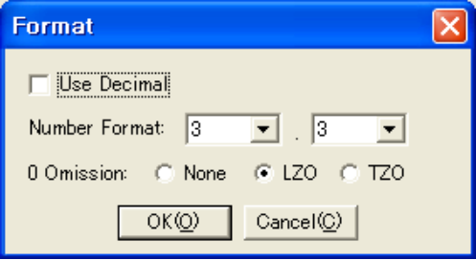
Use Decimal Point
Determine the use of decimal point in the output.
Number Format
0~6 – Select the ciphers of integer part.
0~6 – Select the ciphers after the decimal point.
(e.g.) 123.456mm is expressed as 12345600 by 3.5 format.
0 Omission
- None – No omission
- LZ0 – Continuous 0s from the front are omitted.
- TZ0 – Continuous 0s from the end are omitted.

(e.g.) 123.456mm is expressed by 4.4 format as,
(None) 01234560
(LZO) 1234560
(TZO) 0123456

Option Dialog Box: Drawing Option
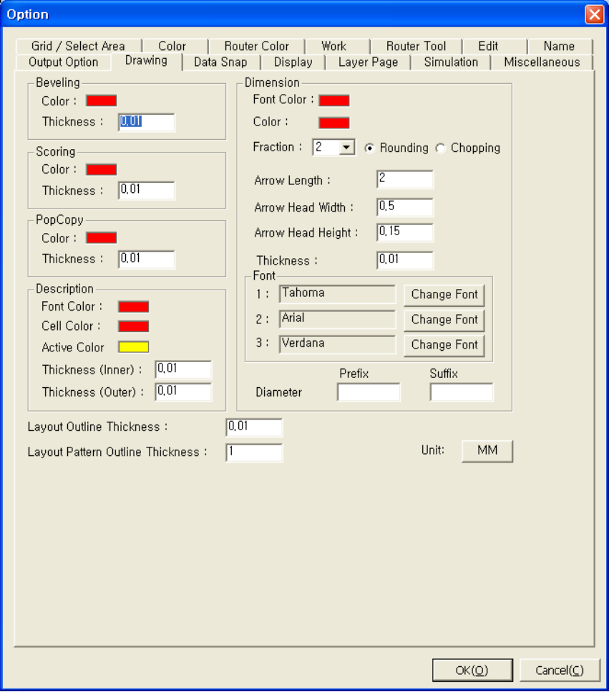
Beveling
Specify the color and the thickness of lines used in beveling. The thickness of a line means the real thickness printed in the drawing.
Scoring
Specify the color and the thickness of lines used in scoring. The thickness of a line means the real thickness printed in the drawing.
PopCopy
Specify the color and the thickness of lines used in the popcopy. The thickness of a line means the real thickness printed in the drawing.
Description
Specify the color and the thickness of lines used in description. The thickness of a line means the real thickness printed in the drawing.

Dimension
- Font Color
Specify the color of the text indicating the value.
- Color
Specify the color of the dimension line.
- Fraction
Specify the rounding option of automatically entered dimensions.
- Arrow
Enter the length information of dimension line arrow.
- Thickness
Specify the thickness of the dimension line.
- Font
Specify the font of the text indicating the dimensions. The basic fonts specified hereby are also used in the scoring, beveling, and table.
- Diameter dimension line (Prefix, Suffix)
Specify the text to add to the front or end of the diameter dimension.
(e.g.) When φis entered for the prefix, it displays φ23.40.
Layout Outline Thickness
Specify the layout outline thickness.

Option Dialog – Data Snap Page
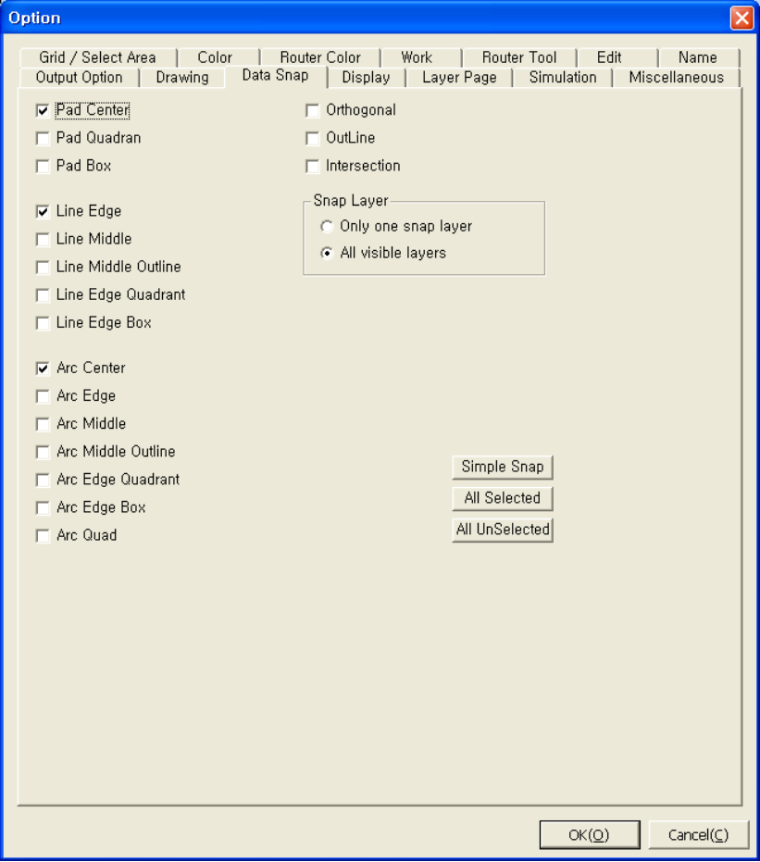
Pad
Specify a snap on the pad.

Pad Center | Pad Quadrant | Pad Box

There are 3 options as above.

Line
Specify a snap on the line.

Line edge | Line Middle |  | Line Middle Outline
Line Edge Quadrant |  | Line Edge Box

There are 5 options as above.
Arc
Specify a snap on the arc.

Arc Center | Arc edge |  | Arc Middle
Arc Middle Outline |  | Arc Edge Quadrant
Arc Edge Box |  | Arc Quadrant

There are 7 options as above.
Orthogonal
Select a point on each vector on which a specific point meets the vector perpendicularly.
Outline
Follow the outline of each vector.
Intersection
Select the intersection of vectors.
Snap Layer
- Only one snap layer: Set only the snap layer specified in the layer bar as snap.
- All visible layers: Set all visible layers as snap, even though they are not snap layers.
Simple Snap
Snap is done only in the basic snap set.
(Basic snap: Pad center, Line edge, Arc center, Arc edge)
All Selected
All snaps are possible.
All UnSelected
Initialize the snap configuration.

Option Dialog Box: Display
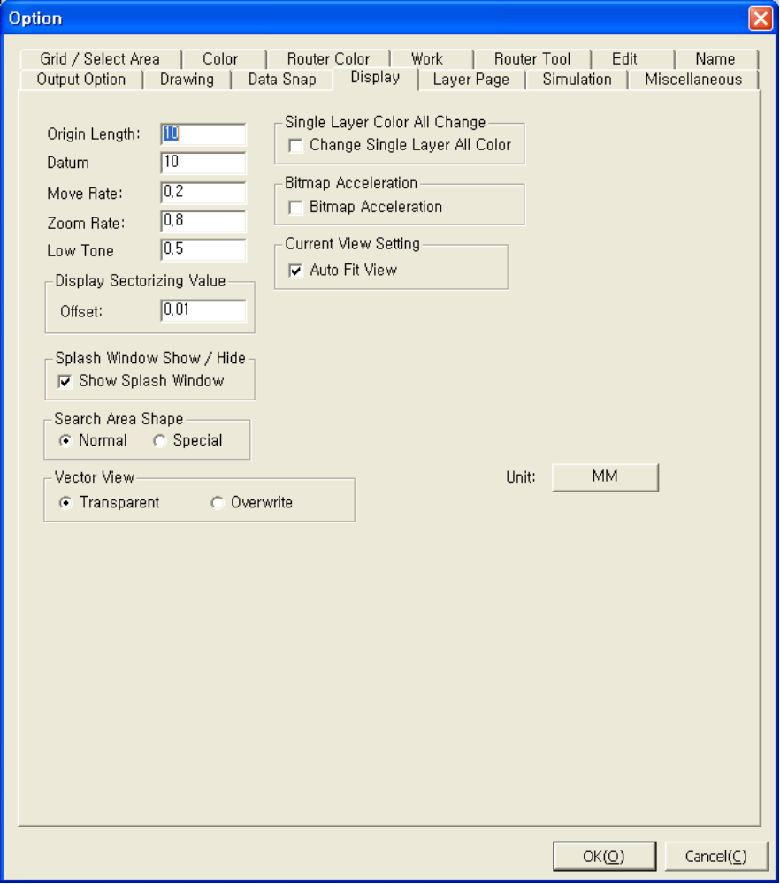
Origin Length
Specify the size of the mark indicating the origin.
Datum Length
Specify the size of the mark indicating the datum.
Panning Rate
Specify the ratio of one move of the left move, right move, up move, and down move.
(e.g.) When 0.2 is entered, the screen moves at a time at the rate of 20% of visible area.
Zoom Rate
Specify the zoom In/Out ratio used in enlarging and shrinking the screen. (0.2~0.8)
The smaller value enlarges or shrinks more.
(e.g.) When 100mm fills the full screen, 80mm fills the full screen by entering 0.8 for enlargement.
Display Sectorizing Value
Specify the offset used in displaying the arc data by sectorizing as lines.
Sectorize by reducing the difference below the given offset.
Splash Window Show / Hide
Show or hide the splash window in executing the program.
Search Area Shape
Specify the shape of the selected area(the rectangular area for selecting data).
Vector View
- Transparent: Mix with the previously drawn layer and the color.
- Overwrite: Overwrite the previously drawn layer, and draw a new layer.
Single Layer Color All Change
Change the color of the pad and the color of the vector(line, arc) at the same time in the layer bar.
Bitmap Acceleration
Improve the speed of drawing bitmap.

Option Dialog – Layer Page
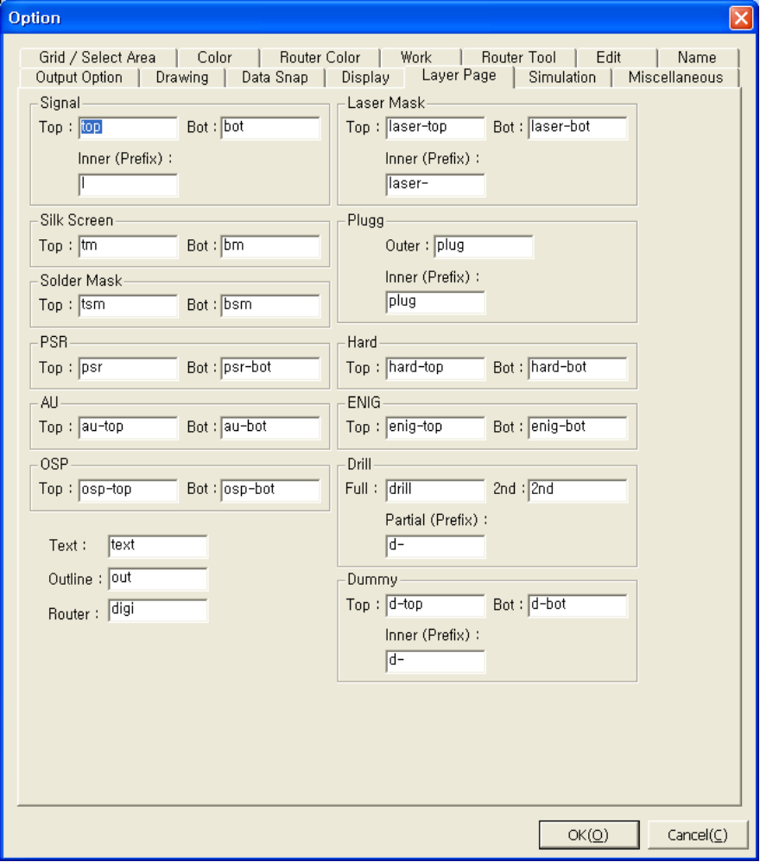
Layer Naming Convention
Enter the reference strings for sorting in importing the layers.

Option Dialog : Simulation
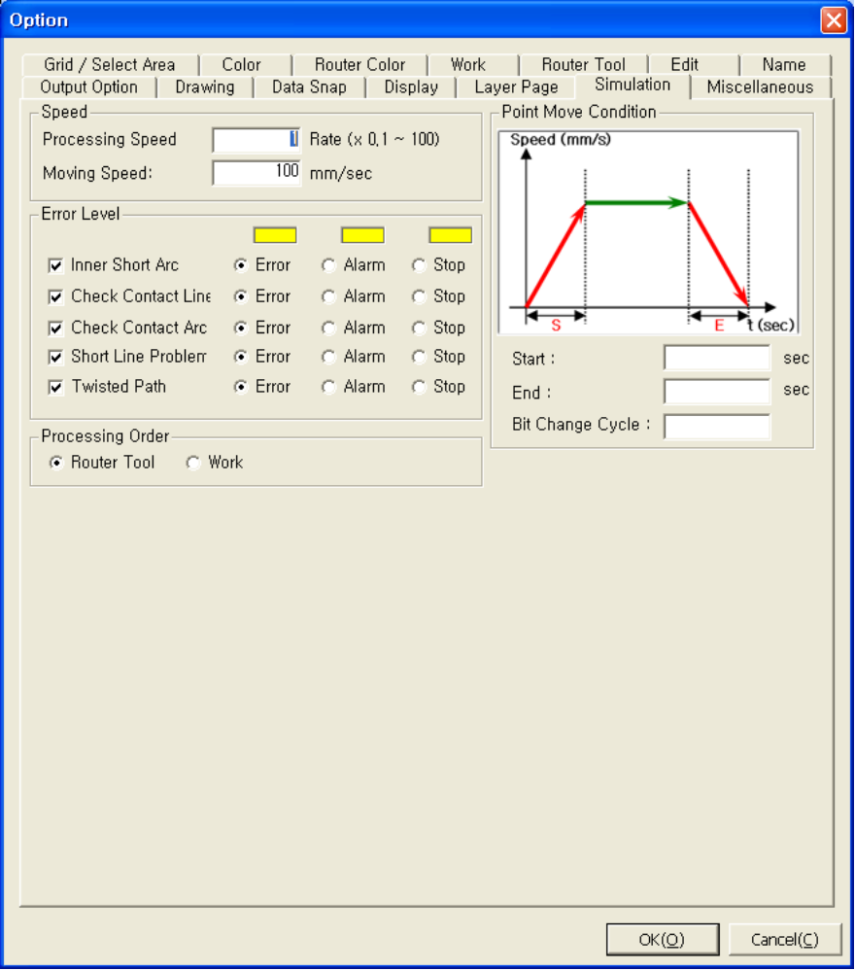
Speed – Simulation Speed
Enter the multiple for the processing speed of a simulation with reference to the tool processing speed.
Move Speed
Enter the moving speed of the tool in non-processing.
Errors
Check error items for the simulation, and specify the viewing method.
- Inner short arc
- Check contact
- Check contact arc
- Short line problem
- Reverse direction

Option Dialog – Miscellaneous
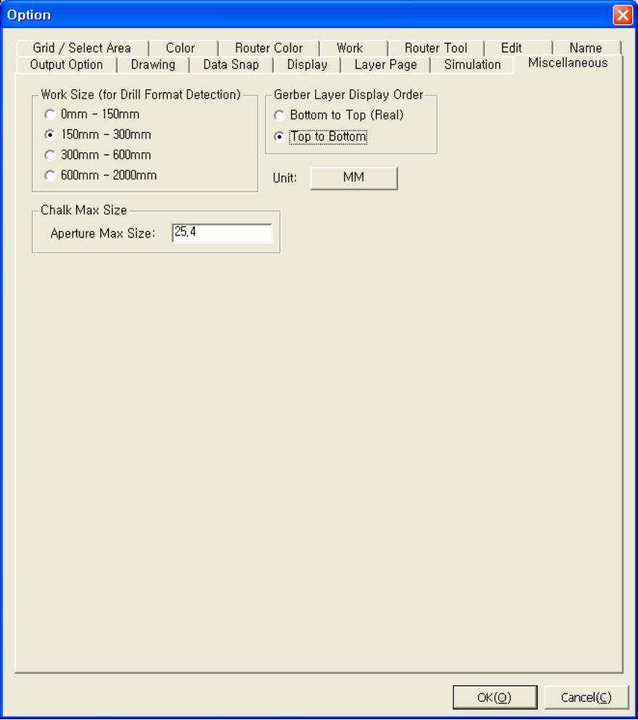
Drill Max Work Size
The size of basic layer used for automatic configuration of drill data format.
Chalk Max Size
Specify the maximum size of the chalk used in editing.
Gerber Layer Display Order
- Bottom to Top (Real): Draw the layer from the bottom to the top in order.
- Top to Bottom: Draw the layer from the top to the bottom in order.

21. Simulation

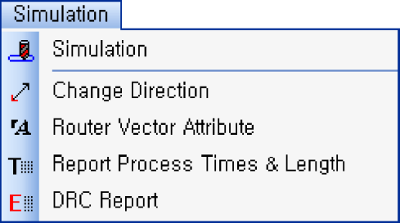 | Simulation
 | Bit simulation.
 | Change Direction
 | Change the direction of the selected vector group.
 | Router Vector Attribute
 | Change the attributes of Router vector.
 | Report Process Times & Length
 | Report processing time and distance by tool.
 | DRC Report
 | Report the DRC test result.

21-1. Simulation
Use this menu to simulate the active layer.

Simulate Bit Dialog
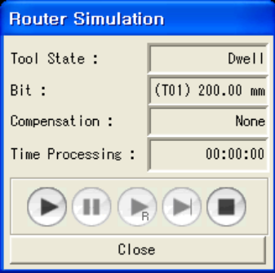
Tool State
Display the state of the current processing tool.
Bit
Display the size of the current processing tool.
Compensation
Display the compensation value of the current processing vector group.
Processing Time
Display the whole processing time.

Buttons
Play, pause, resume, next step, and stop.

21-2. Change Direction
Use this menu to change the direction of selected vector group. After using this menu, the previous start point becomes the new end point, and the previous end point becomes the new start point.

21-3. Router Vector Attribute
Use this menu to change the attributes of the Router vector group.

Change Attributes Dialog
Cutting Type
Change the cutting type.
Tool No
Change the tool.
DCode
Set Dcode.
- Default
- Set as default
- User Defined
- Enter the value for Dcode.
Attribute
Specify the attributes of Router vector group.
- Normal
- For both cutting and drawing.
- Cutting only
- For cutting only
- Paper only
- For drawing only.
Tool Compensation
Specify tool compensation.
- Left:
- Left compensation
- None:
- No compensation
- Right:
- Right compensation

21-4. Report Process Times & Length
Use this menu to see the processing time and distance by tool after simulation.

Report Process Times & Length Dialog
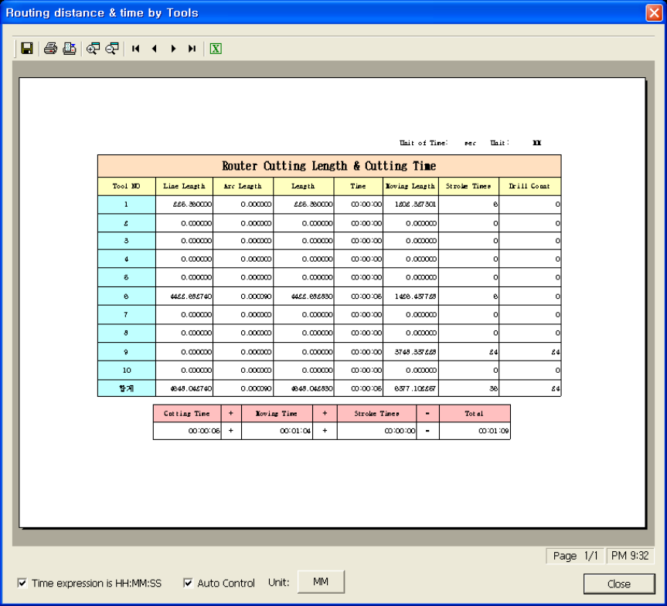
Tool List
Display the list of current tool and processing distance and time by tool.

Total Cutting Time
Display the whole processing time.
Total Moving Time
Display the whole processing distance.
Total Time
Display the whole processing time for moving and processing.
Total UP/DOWN Time
Display Up/Down time of the tool for processing.
Time Expression is HH:MM:SS
- Checked
- Display the time as the form of hour: minute: second.
- Unchecked
- Display the time after converting the whole time to seconds.

21-5. DRC Report
Use this menu to see the DRC text report according to checked items.

DRC Report Dialog
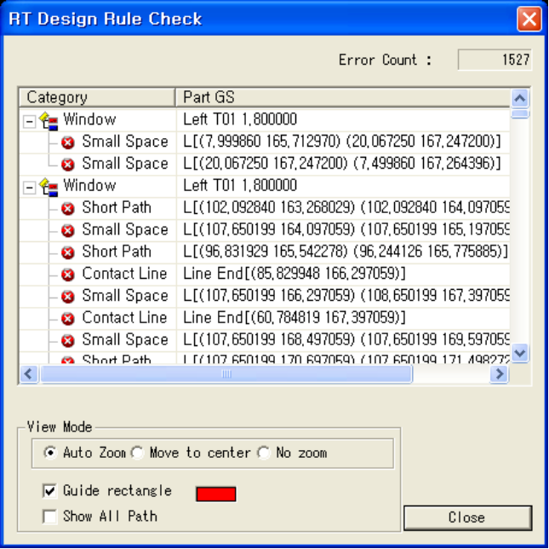
Error Count
The whole number of errors.

Category
Display the location information and error checking method according to each checked item.
View Mode
Specify error viewing method.
- Auto Zoom
- Fit the error section to the screen.
- Move to center
- Move the error section to the center.
- No Zoom
- Display the error section in the current view.
Show Guide Rectangle
Check to see the errors in the rectangular guide.
Show All Paths
Check to see the vectors and errors forming error section, and uncheck to see the error section only.

